**Final Deliverable**

CIS 4911 – Senior Project

Virtual Queue

**Member:**

Kely Cid

**Instructor**

Masoud Sadjadi

**Mentor**

[Bernard Parenteau](http://spws-dev.cis.fiu.edu/senior-project-website-v4/user/231)

**Date**

October 20th 2014

Copyright © Florida International University 2014. All Rights Reserved. No part of the Virtual Queue Project or documentation may be reproduced or modified without the express consent of Florida International University, School of Computing & Information Sciences. Redistribution or commercial use is strictly prohibited. The Software is provided “AS IS”, without warranty of any kind, express or implied, including but not limited to the warranties of merchantability, fitness for a particular purpose, if no event shall the authors or copyright holders be liable for any claim, damage or other liability.

**Executive Summary**

The Virtual Queue System will be designed for theme parks and other businesses that have multiple rides or events for which patrons typically wait in line. The idea is that both the theme park and the patron would benefit by the patrons walking around the park (and maybe spending money) rather than standing in line.

This document gives an introduction to the Virtual Queue System. Chapter 1 gives a basic introduction about the Virtual Queue System, including the problem definition, scope of the system, overall development methodology, definitions, acronyms, and abbreviations, and overview of document. Chapter 2 introduces from the feasibility study the description of the current system identifying limitations and constrains, the description of the alternative solutions considered and explanations of why the solution was selected. Chapter 3 includes the project organization, project personnel and hardware and software resources, the identification of tasks, milestones and deliverables and costs of project. Chapter 4 presents the system requirements, including functional and no functional requirements and requirement analysis. Chapter 5 introduces the system design, subsystem decomposition, hardware and software mapping, persistent data management, and security and privacy of the VQ system. Chapter 6 is the detailed design chapter including static model, dynamic model and code specification. Chapter 7 specifies the subsystem test, system tests, and evaluation of tests. Chapter 8 defines the domain terms used in the document and Chapter 9 contains the Appendixes from A to H in the following order: Project Schedule, All use cases with non functional requirements, User Interface Designs, Analysis Models, Design Models, Documented Class Interfaces and constrains, Documented code for test drivers and stubs, and diary of meetings. Finally chapter 10 shows all references that were used.

Contents

1. Introduction 6

1.1. Problem definition 6

1.2. Scope of System 6

1.3. Overall Development Methodology 7

1.4. Definitions, Acronyms, and Abbreviations 7

1.5. Overview of document 8

2. Feasibility Study 10

2.1. Description of Current System (Limitations and Constraints) 10

2.2. Description of Alternatives 10

2.3. Recommendation with explanation of why the solution was selected. 10

3. Project Plan 11

3.1. Project Organization 11

3.1.1. Project Personnel Organization 11

3.1.2. Hardware and Software Resources 11

3.2 Identification of Tasks, Milestones and Deliverables (work breakdown) 13

3.3 Cost of the Project 15

4. Proposed System Requirements 16

4.1 Functional and Non-Functional Requirements 16

4.2 Analysis of System Requirements 19

4.2.1 Use case model 19

4.2.3 Static model 20

4.2.4 Dynamic model 20

5. System Design (i.e., overall system design) 20

5.1 Overview 20

5.2 Subsystem Decomposition 21

5.3 Hardware-Software Mapping 22

5.4 Persistent Data Management 23

5.5 Security/Privacy 24

6. Detailed Design 25

6.1 Overview 25

6.2 Static models 26

6.3 Dynamic Model 31

6.4 Code Specification 38

7. System Validation 38

7.1 Subsystem Tests 38

7.2 System Tests 38

7.3 Evaluation of Tests 45

8. Glossary 45

9. Appendix 47

9.1 Appendix A - Project schedule (Gantt chart or PERT Chart) 47

9.2. Appendix B – All use cases with nonfunctional requirements 54

9.3. Appendix C – User Interface Designs 66

9.4. Appendix D – Analysis models (static and dynamic) 70

9.5. Appendix E – Design models (static and dynamic) 70

9.6. Appendix F – Documented class interfaces (code) and constrains 82

9.7. Appendix G – Documented code for test drivers and stubs 86

9.8. Appendix H – Diary of Meetings and Tasks for the entire semester 86

10. References 93

# 1. Introduction

The introductory chapter gives some background information about the Virtual Queue system. In the following sections, the problem definition, and scope of the system will be described along with the overall development methodology. In addition, definitions, acronyms, and abbreviations of terms used in this deliverable will be provided and explained on this chapter. Finally, the chapter will conclude with a brief explanation of what to expect from the following chapters of the document.

## 1.1. Problem definition

When going to a park, or to any other venue that provides multiple recurring rides or events, customers typically wait in line until is time for them to go into the ride or event. This is definitely time consuming, since one could be doing something else like be walking around, buying souvenirs, or food, or going perhaps to another ride or event. By waiting in line, the venue is making money for that specific ride/event, but is losing potential additional sales by customers being in line rather than walking around the venue visiting other areas of the venue.

The creation of the Virtual Queue system is the proposed solution to the problem explained above. The system will provide customers the benefit of enjoying other amenities offered in the venue (including, but not limited to rides, food) instead of waiting in line. In addition, the system will keep information about ride or event time and capacity and allow the customers to sign in to different events or rides. In this way, customers will not have the need to wait for a ride in line to go to another one. Furthermore, customers will be notified as their time on their rides or events approaches. At the same time, the business will take advantage of this system because of the fact that customers will now have the opportunity to either sign in to another ride, or walk around to buy souvenirs, food, or something else offered at the specific place.

## 1.2. Scope of System

The main purpose of the Virtual Queue system is to add functionalities and new features to the current system, which will greatly benefit both the customers and the park/event place. The current system requires the customers to buy their tickets and wait in line at the venue until it’s their turn for their event or ride. At some theme parks, there is not even the possibility of buying the ticket for the desired ride online; it has to be purchased by the customers at the theme park.

The VQ will be created with features that will greatly benefit the customers as well as the theme park or other venue using the system. Customers will now be able to login into the system, browse all rides available at the venue park, choose their preferred ones, and add them to their list of rides. Venue registered users will also be able to get a notification before their selected rides/events starts and remove themselves from a registered ride. They will also be able to see all the queues he/she registered and logout when they decide to do so. All functionalities will be created to facilitate and improve the quality time spend at the park or event by customers, and hopefully the sales of the theme park will increase as expected.

## 1.3. Overall Development Methodology

The development methodology used for the VQ system is the Agile Development Model. Using this approach, the whole application grows together. It also allows for the requirements and architecture to change as a better understanding of what the project would become is achieved. Work is divided into small blocks, which allows for development and showcased to the client. It also allows each functionality to be tested once is completed, or feedback from the client is received so that I can go back, reevaluate and make changes until the client requirements are met. The agile development model picture is shown below.

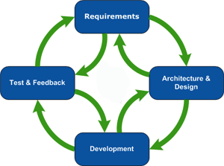

## 1.4. Definitions, Acronyms, and Abbreviations

**Definitions**

* **Customer**: A person or organization that buys goods or services from a store or business.
* **Theme park:** An amusement park with a unifying setting or idea.
* **Alternative:** A possible manner by which a given problem may be resolved.
* **Task:** A piece of job that serves as a unit of work.
* **Guest Users**: Anyone who wants to browse through the site and view offered deals before placing an order.
* **Registered Users**: Users that have already created an online account and can place orders and view previous orders they have requested.
* **System:** The system itself.

**Acronyms**

- **VQ**: Virtual Queue

- **FIU:** Florida International University

- **SCIS:** School of Computing & Information Sciences

**Abbreviations**

As of right now, there are no abbreviations for this project.

## 1.5. Overview of document

The following chapter of this document will cover general information about the project. Chapter 2 introduces from the feasibility study the description of the current system identifying limitations and constrains, the description of the alternative solutions considered and explanations of why the solution was selected. Chapter 3 includes the project organization, project personnel and hardware and software resources, the identification of tasks, milestones and deliverables and costs of project. Chapter 4 presents the system requirements, including functional and no functional requirements and requirement analysis. Chapter 5 introduces the system design, subsystem decomposition, hardware and software mapping, persistent data management, and security and privacy of the VQ system. Chapter 6 is the detailed design chapter including static model, dynamic model and code specification. Chapter 7 specifies the subsystem test, system tests, and evaluation of tests. Chapter 8 defines the domain terms used in the document and Chapter 9 contains the Appendix, in which miscellaneous information, such as charts and tables are shown. Finally chapter 10 shows all references that were used.

# 2. Feasibility Study

The feasibility study chapter explores the idea of a virtual queue from a practical point of view. Initially, it considers the fact that there is no system developed in charged of completing the desired tasks. In addition, it describes the alternative solution considered and explanation of why the solution was selected.

## 2.1. Description of Current System (Limitations and Constraints)

The current system requires the customers to buy their tickets and wait in line at the venue until it’s their turn for their event or ride. At some theme parks, there is not even the possibility of buying the ticket for the desired ride online; it has to be purchased by the customers at the theme park. There is no mechanism to allow the user to register and sign in to see the available rides and select the rides they want; or to logout when they decide to do so; or to allow registered users to log in and logout. It lacks of a system that allows the user the ability to be added to their selected rides. It does not have a system with the ability to allow the user to see all the queues he/she registered. There is no mechanism for adding/removing registered users from the queue according to the queuing algorithm, or to allow users to remove themselves from a registered ride. There is no system with the capability of notifying the users before their selected rides/events starts.

## 2.2. Description of Alternatives

The alternative for this project is to build a new system from scratch. This will give the ability and control required over the architecture of the system. Furthermore, all features will be implemented from the beginning. There will be no need of modifying any existing code, which will increase the efficiency of programming.

## 2.3. Recommendation with explanation of why the solution was selected.

The alternative described above is the only option available for this project. Taking into account this is the first version of this system, there is no other platform that was provided to modify or extend. Therefore, starting this project implementation from the beginning is the only and best option to develop the system and implement all new functionalities. So, the conclusion is to start building the project from the beginning. Since there is no previous platforms implemented that can be take into consideration, the only and best solution is to start from scratch. The implementation of the new system will provide functionalities that will make the new system easier and better.

# 3. Project Plan

This chapter introduces the VQ system a project management perspective. First of all, the project organization that is going to be used will be described, with all roles listed. Following, hardware and software required in order to develop the project will be listed. Finally, tasks, milestones, and deliverables will also be listed.

## 3.1. Project Organization

For this project, I will be in charge of all functionality and roles of the system.

|  |  |  |  |  |
| --- | --- | --- | --- | --- |
| Name | Roles | Tasks | Periods required | Key Phases |
| Kely Cid | * Project Manager * Developer * Test Engineer * Document Editor | * Project Status * Schedule/Tasks * Test Results * Implementation Integration * Project Documentation (Deliverables) * Any other additional tasks | 9/1/14  to 12/12/14 | All |

### 3.1.1. Project Personnel Organization

All sections of this project will be assigned to the only member of the group, which will be in charge to develop all the components needed to support the different functionalities.

### 3.1.2. Hardware and Software Resources

**Hardware**

The following are the specification of the computer that will be used for the development of this project:

**Laptop with:**

**- Processing Power:** 1.8 GHz Intel Core i5

**- RAM Memory:** 4 GB 1600 MHz DDR3

**- Available space on hard drive:** 128 GB flash storage

**Other Devices**

- **Input devices**

a) Keyboard- Standard keyboard

b) Mouse- Trackpad mouse

- **Output devices**

a) Monitor display- 13-inch (1440 x 990) Intel HD Graphics 4000 graphics

**Software**

1. **Safari 7.0.6:** last, most updated version of the Safari browser that will be used to test Virtual Queue.
2. **Google Chrome 37.0:** last, most updated version of the Google Chrome browser that will be used to test Virtual Queue.
3. **Spring Framework 4.0:** last, most updated version of Spring Framework, an MVC-based, Java framework used for development. It will be used to develop the front-end and back-end of Virtual Queue.
4. **Spring JDBC template**: make database call access to MySQL database.
5. **MySQL**: database that will be used to store data for the Virtual Queue system.
6. **StarUML:** UML software platform that will be used to create diagrams for the document.
7. **VMWare:** virtual machine software that will be used for the deployment of the software.
8. **Eclipse Luna:** IDETool software used to write the java classes for the Virtual Queue system.
9. **JBoss 7.1.1**: Java J2EE Application Server used to deploy and run the Virtual Queue system.

## 3.2 Identification of Tasks, Milestones and Deliverables (work breakdown)

Below is a list of all different tasks, milestones, and deliverables for the project, which can be changed according to the development of the project:

|  |  |
| --- | --- |
| Milestones | Task & Deliverables |
| Documentation | * Feasibility Study * Requirement Document * Design Document * Deliverable 4 |
| Environment Setup | * IDE Installation (Eclipse) * JDK 8 Install * StartUML Install * Source Tree for Github * Jboss Installation and Configuration * Maven Project Setup * Spring framework setup * Project dependencies and third parties libraries * Dependency injections setup * MySQL install |
| * Development Tasks: | |
| UI Design | * Create main page template view * Create login page template view * Create My Account page template view * Create Add ride to user page template view * Create Select User template view * Create reset password page template view * Create Add User page template view |
| Database Design and Implementation | * Create Tables * Create tables relationships and constrains * Create EER diagram |
| Main Page Functionality | * Add dynamic content to main page. (JQuery, Ajax calls) * Add server side implementation to main page. * Create main controller with URL definitions and contracts * Create main service interface/implementation * Create main DAO for data access. |
| Login and Logout functionalities | * Add dynamic content to login page (JQuery, Ajax calls) * Server Side Implementation. * Create login controller with URL definitions and UI contracts * Login controller unit test. * Create user Bean. * Unit test to user bean. * Add user information to session when user log * Create login service interface/Implementation * Login service unit test * Create login DAO to facilitate data access * DAO unit test. * Add logout controller with URL contract * Logout controller unit test. * Remove user information from session data. * Unit test. |
| Add User Functionality | * Add to add user page (JQuery, Ajax calls) * Server Side Implementation. * Create User controller with URL definitions and UI contracts * User controller unit test. * Add User information to session when user log * Create User service interface/Implementation * User service unit test * Create User DAO to facilitate data access * DAO unit test. |
| Reset Password Functionality | * Add dynamic content to user page to reset password (JQuery, Ajax calls) * Server Side Implementation. * Add method User controller with URL definitions and UI contracts for password reset. * User controller unit test. * Add functionality to User service interface/Implementation * User service unit test * Add functionality to User DAO to facilitate data access * DAO unit test. |
| User Ride Functionality | * Add dynamic content to user Ride page (JQuery, Ajax calls). * Add UI data validations. * Server Side Implementation. * Create login controller with URL definitions and UI contracts * Add controller unit test * Create Ride Bean. * Unit test to ride bean. * Add user information to session when user log * Create user ride interface/Implementation * Unit test for service interfaces * Create User Ride DAO to facilitate data access * DAO unit test. * Add User Validator interface when registering for a ride. * Validator unit test. * Add User validator implementation with rule definitions. * Validator implementation unit test for each method. * =================================== * Add Ride Registration Business Rules Interface * Add Ride Registration Business Rule implementation. * Add Unit test for Ride Registration * Add Rules Interfaces * Add Rules Implementations. * Add unit test to Rules implementations. * Add Rule Builder Class. * Unit test to Rule Builder. |

## 3.3 Cost of the Project

The cost estimate for each activity will be calculated taking into consideration all the work required to complete the whole project. We will look at human resources and non-human resources costs. The human resources cost will be calculated by the total hours it will be spent to develop the whole project through the entire semester. The non-human resources will be calculated taking into account all hardware and software used in order to develop and complete the whole project.

|  |  |
| --- | --- |
| **Human resource** | **Work (hours)** |
| **Kely Cid** | 520 (13 weeks x 8 daily hors) |

|  |  |  |
| --- | --- | --- |
| **Non-human Resources** | **Quantity** | **Cost** |
| **PC (Hardware)** | 1 | $0.00 |
| **MYSQL** | 1 | $0.00 |
| **Development** |  | $0.00 |
| **Testing** |  | $0.00 |
| **Total Costs** |  | $0.00 |

# 4. Proposed System Requirements

The proposed system is called Virtual Queue, which will give users the functionality to sign in/out of the system of different rides/events, see all the rides they signed on for and received notifications. This chapter will include the functional and non-functional requirements of the system and the requirements analysis phase of the system.

## 4.1 Functional and Non-Functional Requirements

The system shall successfully allow guest users to register.

* **Usability**: No previous training time. System is simple and easy to follow.
* **Reliability**: The system should perform correctly 99% of the time.
* **Performance**: The system should be sent and saved within 3 seconds.
* **Supportability**: The system should be easy to maintain, make appropriate changes, and be correctly handled by IE, Mozilla, Chrome and Safari.

The system shall successful allow users to validate their account.

* **Usability**: No previous training time. System is simple and easy to follow.
* **Reliability**: The system should perform correctly 99% of the time.
* **Performance**: The system should be sent and saved within 3 seconds.
* **Supportability**: The system should be easy to maintain, make appropriate changes, and be correctly handled by IE, Mozilla, Chrome and Safari.

The system shall successful allow registered users to disable their accounts.

* **Usability**: No previous training time. System is simple and easy to follow.
* **Reliability**: The system should perform correctly 99% of the time.
* **Performance**: The system should be sent and saved within 3 seconds.
* **Supportability**: The system should be easy to maintain, make appropriate changes, and be correctly handled by IE, Mozilla, Chrome and Safari.

The system shall successful allow registered users to sign in to their accounts.

* **Usability**: No previous training time. System is simple and easy to follow.
* **Reliability**: The system should perform correctly 99% of the time.
* **Performance**: The system should be sent and saved within 3 seconds.
* **Supportability**: The system should be easy to maintain, make appropriate changes, and be correctly handled by IE, Mozilla, Chrome and Safari.

The system shall successfully reset user’s password upon user request and after confirming his/her identity.

* **Usability**: No previous training time. System is simple and easy to follow.
* **Reliability**: The system should perform correctly 99% of the time.
* **Performance**: The system should be sent and saved within 3 seconds.
* **Supportability**: The system should be easy to maintain

The system shall successful allow registered users to logout of their account.

* **Usability**: No previous training time. System is simple and easy to follow.
* **Reliability**: The system should perform correctly 99% of the time.
* **Performance**: The system should be sent and saved within 3 seconds.
* **Supportability**: The system should be easy to maintain, make appropriate changes, and be correctly handled by IE, Mozilla, Chrome and Safari.

The system shall successful allow registered users to have access to the available rides/events.

* **Usability**: No previous training time. System is simple and easy to follow.
* **Reliability**: The system should perform correctly 99% of the time.
* **Performance**: The system should be sent and saved within 3 seconds.
* **Supportability**: The system should be easy to maintain, make appropriate changes, and be correctly handled by IE, Mozilla, Chrome and Safari.

The system shall successful allow registered users to select their favorite rides/events.

* **Usability**: No previous training time. System is simple and easy to follow.
* **Reliability**: The system should perform correctly 99% of the time.
* **Performance**: The system should be sent and saved within 3 seconds.
* **Supportability**: The system should be easy to maintain, make appropriate changes, and be correctly handled by IE, Mozilla, Chrome and Safari.

The system shall successful allow registered users to be added to their selected rides/events.

* **Usability**: No previous training time. System is simple and easy to follow.
* **Reliability**: The system should perform correctly 99% of the time.
* **Performance**: The system should be sent and saved within 3 seconds.
* **Supportability**: The system should be easy to maintain, make appropriate changes, and be correctly handled by IE, Mozilla, Chrome and Safari.

The system shall successful allow registered users to see all the rides/events they signed on for.

* **Usability**: No previous training time. System is simple and easy to follow.
* **Reliability**: The system should perform correctly 99% of the time.
* **Performance**: The system should be sent and saved within 3 seconds.
* **Supportability**: The system should be easy to maintain, make appropriate changes, and be correctly handled by IE, Mozilla, Chrome and Safari.

The system shall successful allow registered users to delete themselves from registered rides/events.

* **Usability**: No previous training time. System is simple and easy to follow.
* **Reliability**: The system should perform correctly 99% of the time.
* **Performance**: The system should be sent and saved within 3 seconds.
* **Supportability**: The system should be easy to maintain, make appropriate changes, and be correctly handled by IE, Mozilla, Chrome and Safari.

The system shall successful allow adding and/or removing registered users from their selected rides according to the queuing algorithm.

* **Usability**: No previous training time. System is simple and easy to follow.
* **Reliability**: The system should perform correctly 99% of the time.
* **Performance**: The system should be sent and saved within 3 seconds.
* **Supportability**: The system should be easy to maintain, make appropriate changes, and be correctly handled by IE, Mozilla, Chrome and Safari.

The system shall successful allow the user to be notified before their rides/events time occur (i.e: 10 min before).

* **Usability**: No previous training time. System is simple and easy to follow.
* **Reliability**: The system should perform correctly 99% of the time.
* **Performance**: The system should be sent and saved within 3 seconds.
* **Supportability**: The system should be easy to maintain, make appropriate changes, and be correctly handled by IE, Mozilla, Chrome and Safari.

The system shall successful allow to store and retrieve information regarding to the rides/events.

* **Usability**: No previous training time. System is simple and easy to follow.
* **Reliability**: The system should perform correctly 99% of the time.
* **Performance**: The system should be sent and saved within 3 seconds.
* **Supportability**: The system should be easy to maintain, make appropriate changes, and be correctly handled by IE, Mozilla, Chrome and Safari.

The system shall successful allow to check for duplicates registration or multiple registrations for same user.

* **Usability**: No previous training time. System is simple and easy to follow.
* **Reliability**: The system should perform correctly 99% of the time.
* **Performance**: The system should be sent and saved within 3 seconds.
* **Supportability**: The system should be easy to maintain, make appropriate changes, and be correctly handled by IE, Mozilla, Chrome and Safari.

The system shall successful allow to handle network connectivity issues.

* **Usability**: No previous training time. System is simple and easy to follow.
* **Reliability**: The system should perform correctly 99% of the time.
* **Performance**: The system should be sent and saved within 3 seconds.
* **Supportability**: The system should be easy to maintain, make appropriate changes, and be correctly handled by IE, Mozilla, Chrome and Safari.

## 4.2 Analysis of System Requirements

This section includes subsections that present the use case model of the VQ system, the static model, and the dynamic model consecutively.

### 4.2.1 Use case model

The use case diagram describes the list of steps that defines the interaction between the three types of users displayed in the diagram: venue guest user, venue registered user, and single venue admin and the system. They all work together to accomplish the goal of the proposed system. Below is the Use Cases Diagrams using UML for specific details with the specific functionalities that were implemented.

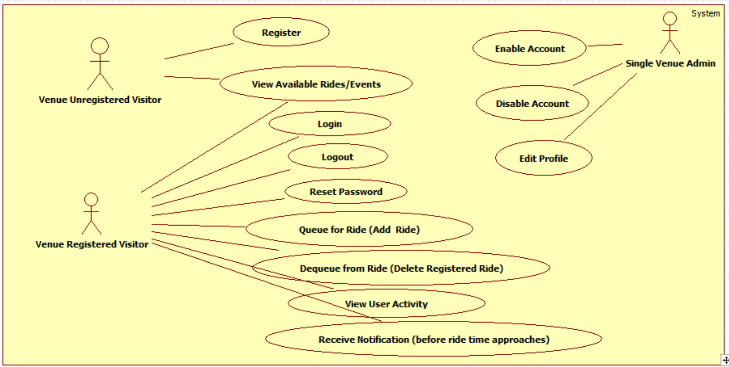

### 4.2.3 Static model

A static model expresses the system and does not account for sequence of events or time. For the VQ system, a class diagram will be included. The diagram will display the structure of system by showing the classes, attributes, methods, and the relationship between these classes. On Appendix D, the static diagram will be shown.

### 4.2.4 Dynamic model

On the other hand, the dynamic model does account for time. For the VQ system, sequence diagrams will be included. These will show objects and class interactions in a sequence of events arranged in a time line that displays functionality in order to allow the developers and programmers to view how the users should transition based on these actions. On Appendix D, the dynamic diagram will be shown.

# 5. System Design (i.e., overall system design)

This chapter will describe the system and subsystem design. It will explain the decomposition of the VQ by giving an overview of the system design architecture. It will provide a detailed description of the subsystem decomposition for each major subsystem. It will cover how the hardware and software are mapped. It will identify the persistent data management that needs to be stored and the structure of the data. Lastly, it will describe security and privacy user authentication processes, encryption of data and all other security parameters being implemented.

## 5.1 Overview

For the VQ system, a three tier and a multilayer architecture were used. The design approach chosen for the VQ system will allow for horizontal scalability, which will let an increment of number of instances on the server side without affecting the UI tier, and multi-cluster environment, which easily handles high volume traffic. Also, it will allow for a thin client principle that will have a faster UI response since all the presentation logic happens on the browser. In addition, the design architecture was built around a resource presentation logic using REST principles for all the UI and server side integration. The VQ system is composed by different logical components, which are: UI subsystem, User Operations subsystem, Ride, Operations subsystem, Queue Scheduler subsystem, Authorization and Authentication subsystem, and Notification API subsystem. Below is an basic illustration showing the different tiers and layers inside the VQ system.

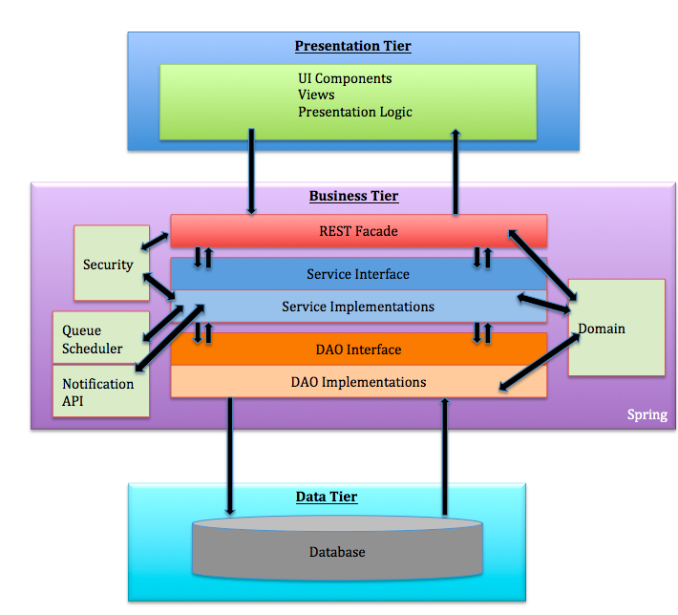

## 5.2 Subsystem Decomposition

The Virtual Queue (VQ) system shall be divided into five main subsystems. Each subsystem follows a multilayer architecture that allows decoupling each layer using interfaces contracts only to communicate between the layers. All subsystem components are using spring framework, which use inversion of control and dependency injection framework.

User Interface: The user interface subsystem is composed of the web pages that the user will interact with in order to provide info about all rides offer in the venue. It will provide the user the ability to register into the VQ system, signing and see all available rides, select them, queue themselves to different rides and be notified as their time for the rides approaches, they can also de-queue themselves from the ride and logout among others functionalities.

User Operations: The user operation subsystem will group all the artifacts around the user business logic, including all layers architectures of the system such as: controllers, business services, Data access objects, and schedulers. This subsystem also provides user REST interface business services such as: register users on the system, and business validations for users.

Login/Logout Operation: The login operation subsystem will provide system permissions to allow user or admin of the VQ system access to specific resources based on their permissions and roles they are assign to.

Ride Operations: The ride operation subsystem will group all artifacts around the ride business logic, including all layers architectures of the system such as controllers, business services, data access objects, validations, and domains. This subsystem also provides ride REST interface business services such as: add, delete, remove user from a specific queue, update and select new rides to the VQ system.

Queue Scheduler: The queue scheduler subsystem will schedule jobs based on business requirements. For example, the VQ system will schedule a job based on the ride properties to interact with the notification API to be able to notify users before their time approaches on a ride they queued for. This subsystem uses open source scheduler that provides underlying quartz functionalities.

Notification API: The notification API subsystem will notify the user before their time for a ride they queued for approaches based on a particular implementation, such as: email notification, SMS notification, in this way, the notification API only exposes their interfaces so that it is decoupled from the caller.

## 5.3 Hardware-Software Mapping

To map the hardware and software used for the Virtual Queue system, a deployment diagram was constructed. It is being hosted on a virtual machine with windows 7 running with JBoss 7.1 application server and Spring 4.0 framework and MySQL database on the FIU SCIS network. Below is the representation of it.

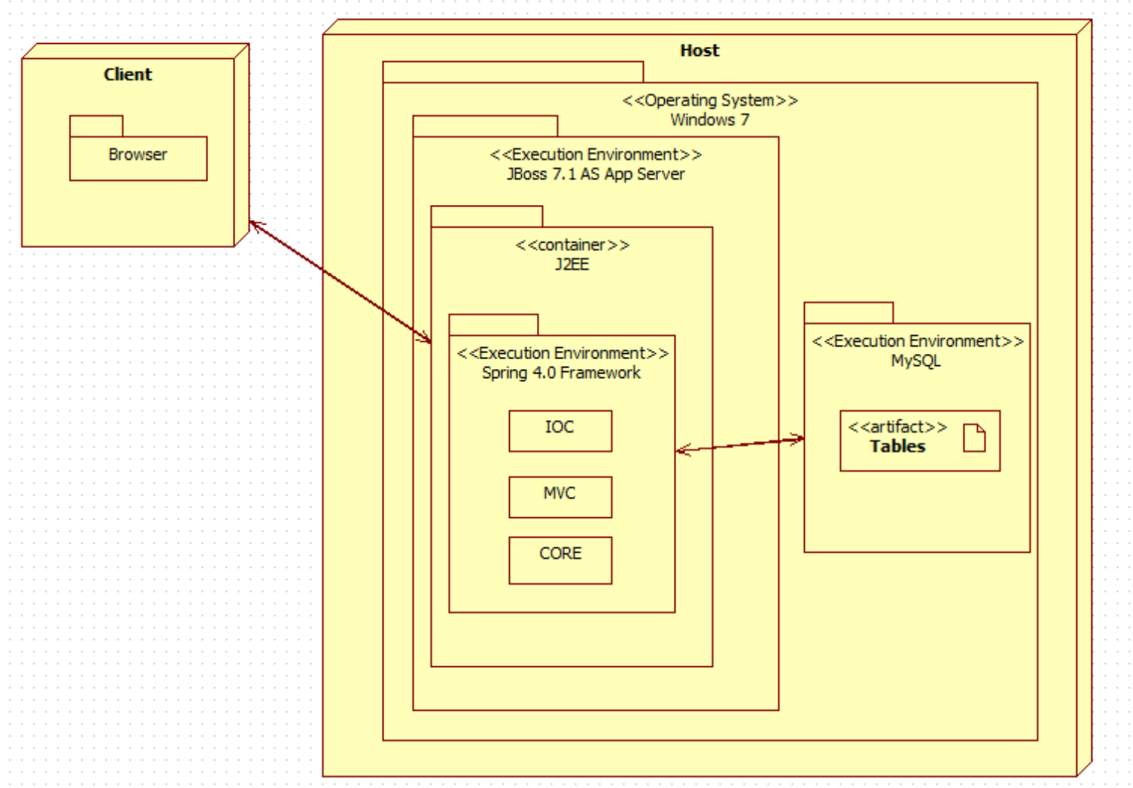

## 5.4 Persistent Data Management

For the VQ system a database was implemented from scratch, taking into account all the information needed to be stored and support the each functionality. Below is the EER diagram schema with all the tables and relations.

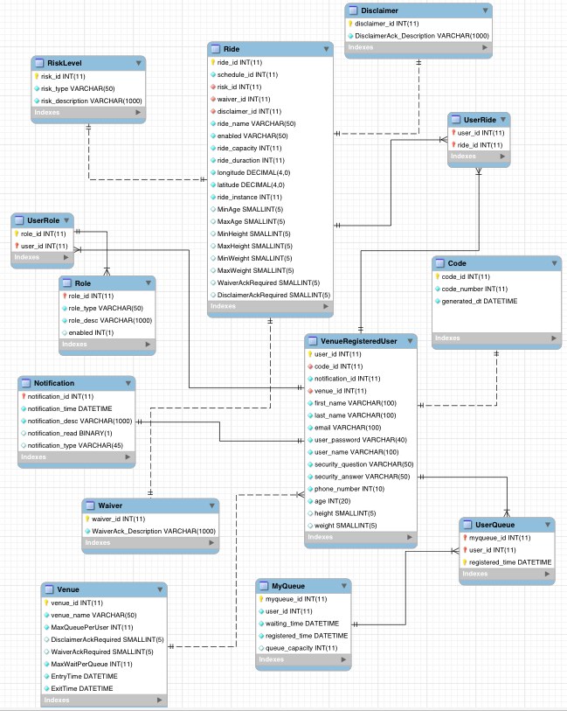

## 5.5 Security/Privacy

For the VQ system all data is password protected. Authentication of each registered user and administrators will be done by checking the database for a registered email, which will be the username as well; also, the table Role and User Role will be checked as well to determine user privileges. Registered users will only have access to their information, and their own data. On the other hand, administrators will have access to all registered users information and results.

# 6. Detailed Design

The detailed design of the VQ system is considered an abstract that translate to source code in a clear way. That is one of the reasons that it has to be detailed and clear. The detailed design chapter will present the system design in a variety of views where each uses a variety of modeling techniques. This chapter is composed for four sections. Section 3.1 is the overview of the chapter; it will give a brief description of the behavior and structure of each subsystem. Section 3.2 contains the static models of each subsystem, and Section 3.3 the dynamic model, which will provide the different diagrams for each subsystem. Section 3.4 delivers the class interfaces and constraints for the main control object in each system.

## 6.1 Overview

The VQ system that is to be created will be composed of various subsystems. Each subsystem will be group by a particular functionality. The user operation system components consists of venue unregistered user, venue registered user, and single venue admin who are required to provide an username, which will be their email, a password, and a code that will be provided on the bottom of the user ticket when they get into the venue. It will also provide user REST interface business services such as: register users on the system, sign in and out users, add users to a particular ride, remove user from a specific queue, and business validations for users. Another important system component of the VQ system is the ride operation component ride which have a REST interface business services such as: add, delete, update and select new rides to the VQ system.

For the VQ system different design patterns were used. The MVC design pattern uses spring MVC framework to provide a web façade for the UI tier. It exposes application resources thru controllers and response request object serving the UI with data. Also, the factory method design pattern is use by the queue scheduler to create jobs, and triggers. In addition, it creates an object without exposing instantiation to the caller. Business Delegate Pattern is used to decouple the web facade layer and business layer. The controller delegates all the responsabilities of business logic to the service layers so that the controllers do not have any responsibility or knowledge on how the business logic is implemented. This pattern allows scalability and low coupling on the VQ system. The REST façade design pattern is also use to allow the VQ to expose all the system functionality thru resources and well define interfaces. Also, it does not stores any state between the communication from the user to the server, which let the system work and perform faster. It resolves issues with versioning and system deployments. The layered architecture design pattern is also used to define each layer based on the principle responsibility principle, which dictates that each layer only knows what its responsibility is and interact with the layer underneath thru the interface only. Lastly, Inversion of Control design pattern is use thru the spring IoC container. All the services and DAO’s are injected thru their interfaces at runtime so that the container is responsible for creating and destroying objects. This makes the VQ system application to have more memory efficiently with better performance.

## 6.2 Static models

To represent the Virtual Queue system static model, each subsystem explained in the section 5.2 (Subsystem Decomposition) was individually represented into a class diagram that describes the behavior and structure of the system so that it will be easier to understand. Below, the figures from 6.2.1 to 6.2.5 are presented.

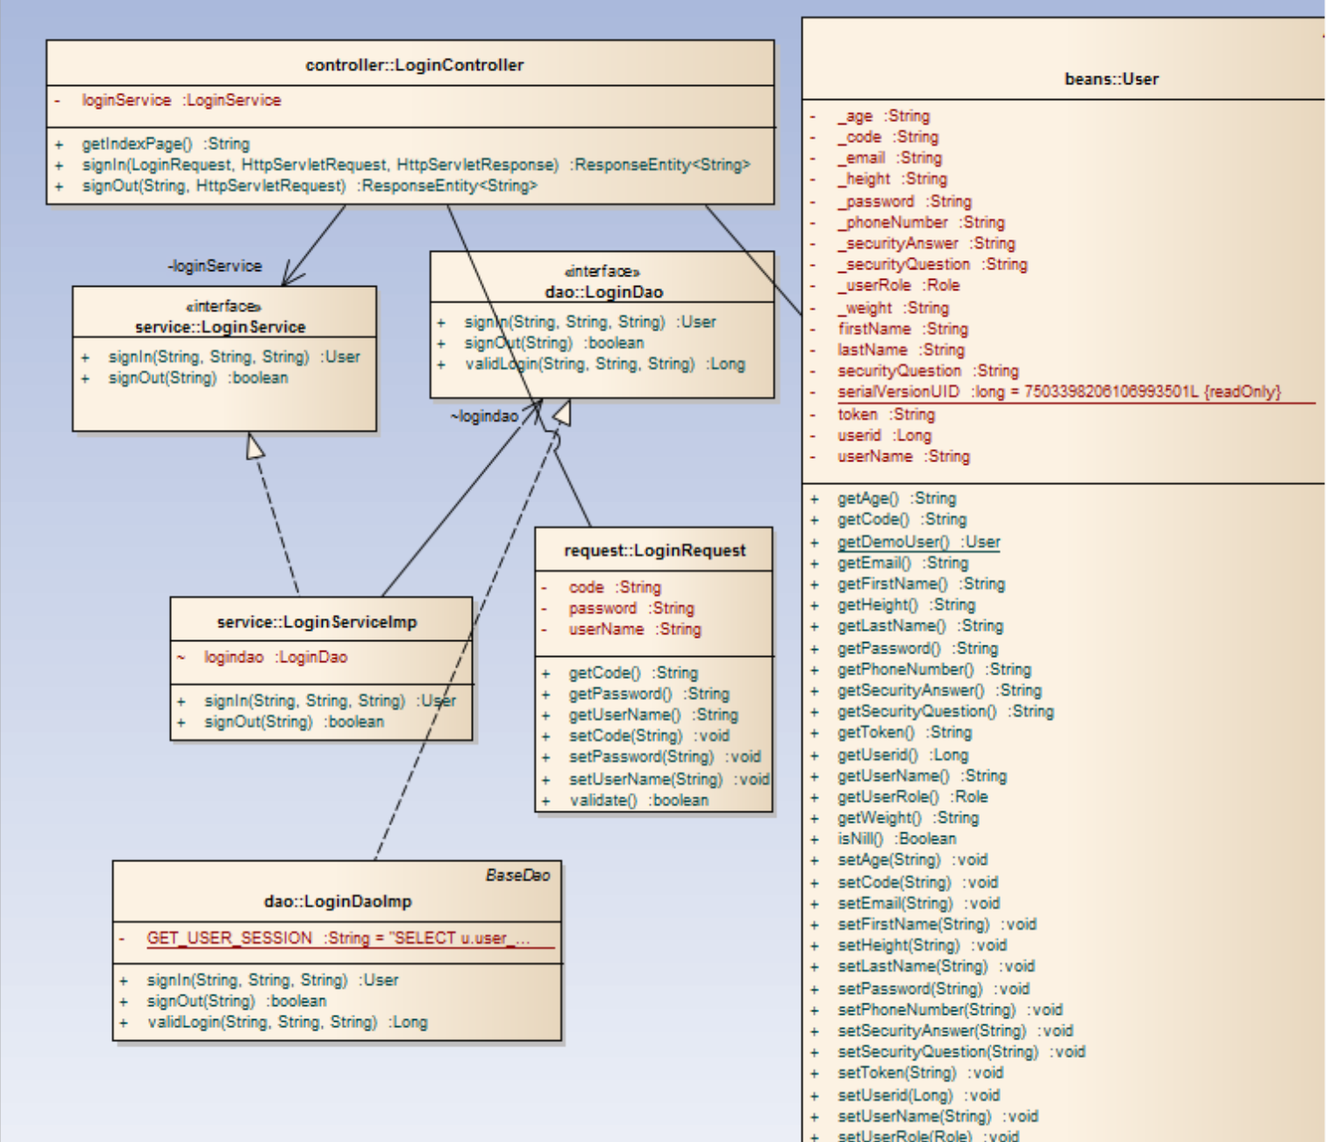

**Fig 6.2.1: Login Operation Subsystem class diagram (part of the whole VQ class Diagram):**

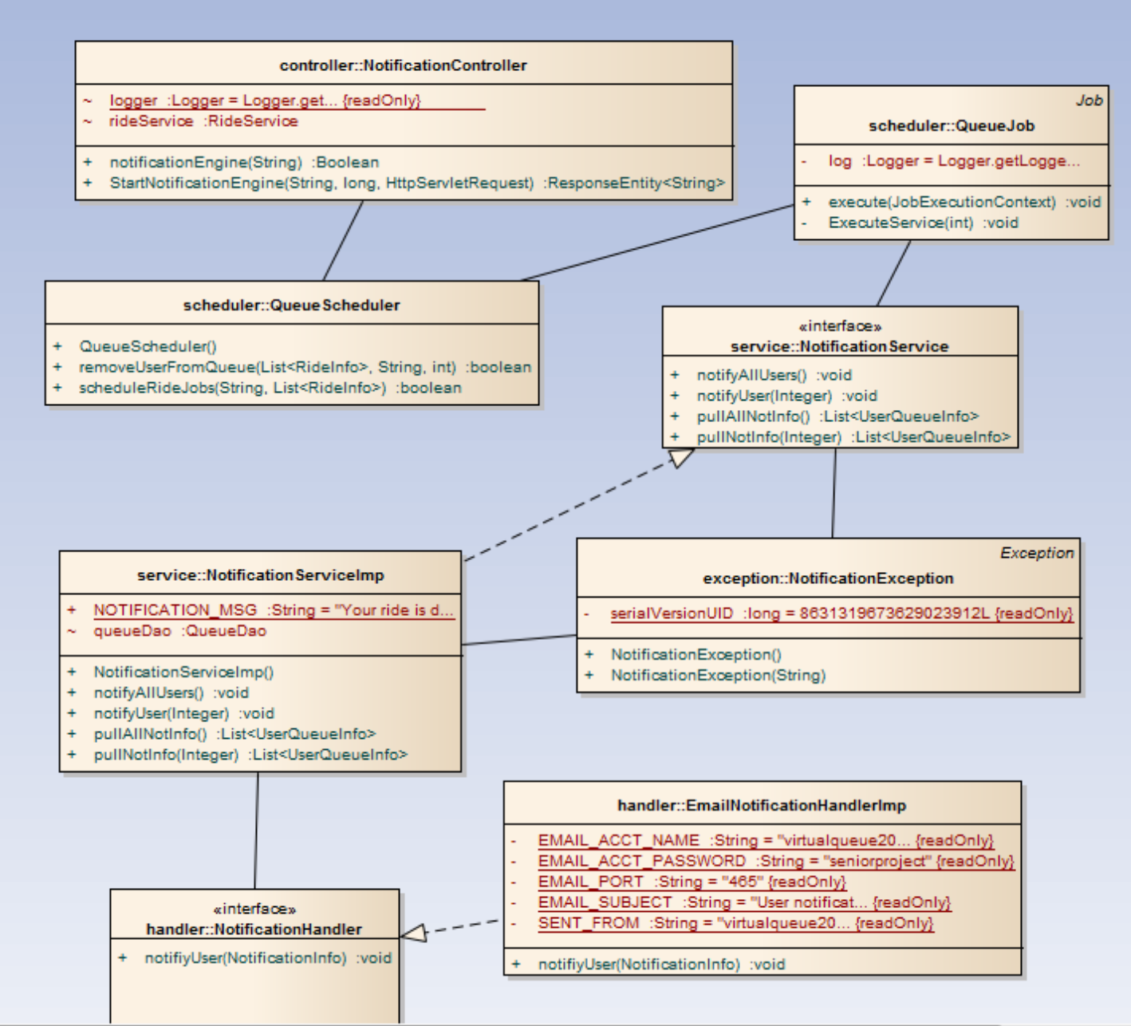

**Fig 6.2.2: Notification API Subsystem class diagram (part of the whole VQ class Diagram)**

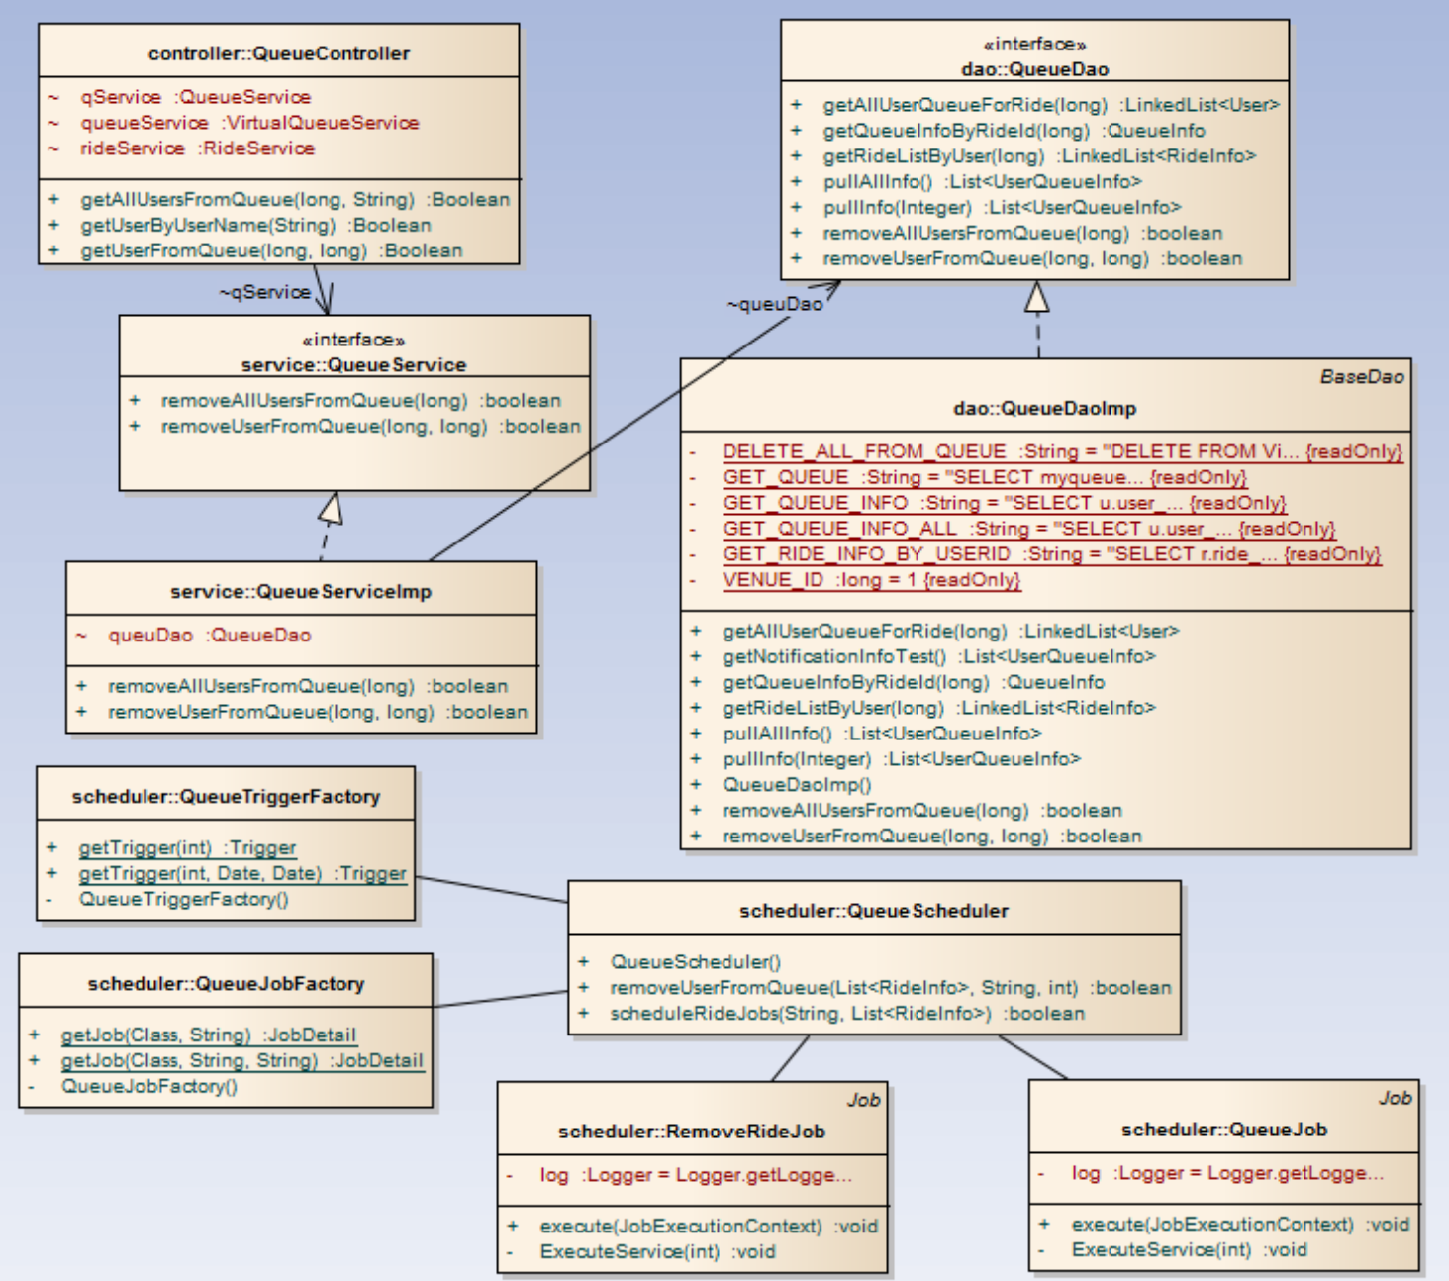

**Fig 6.2.3: Queue Scheduler Subsystem class diagram (part of the whole VQ class Diagram)**

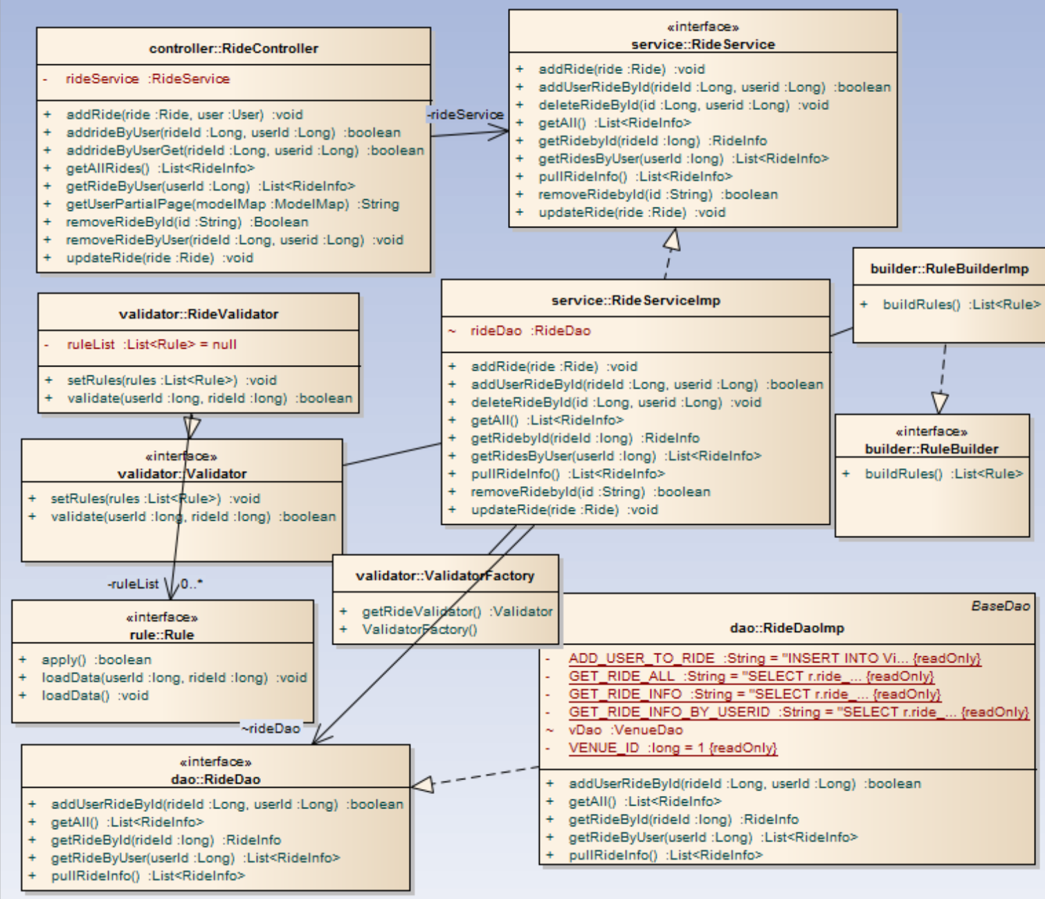

**Fig 6.2.4: Ride Operation Subsystem class diagram (part of the whole VQ class Diagram)**

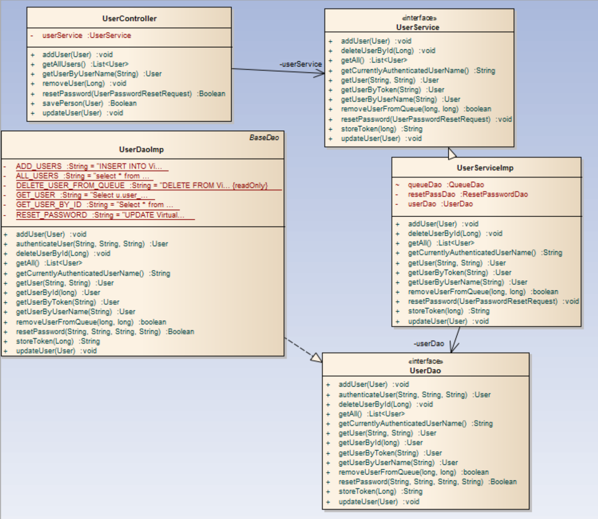

**Fig 6.2.5: User Operation Subsystem class diagram (part of the whole VQ class Diagram)**

## 6.3 Dynamic Model

VQ01-Login:

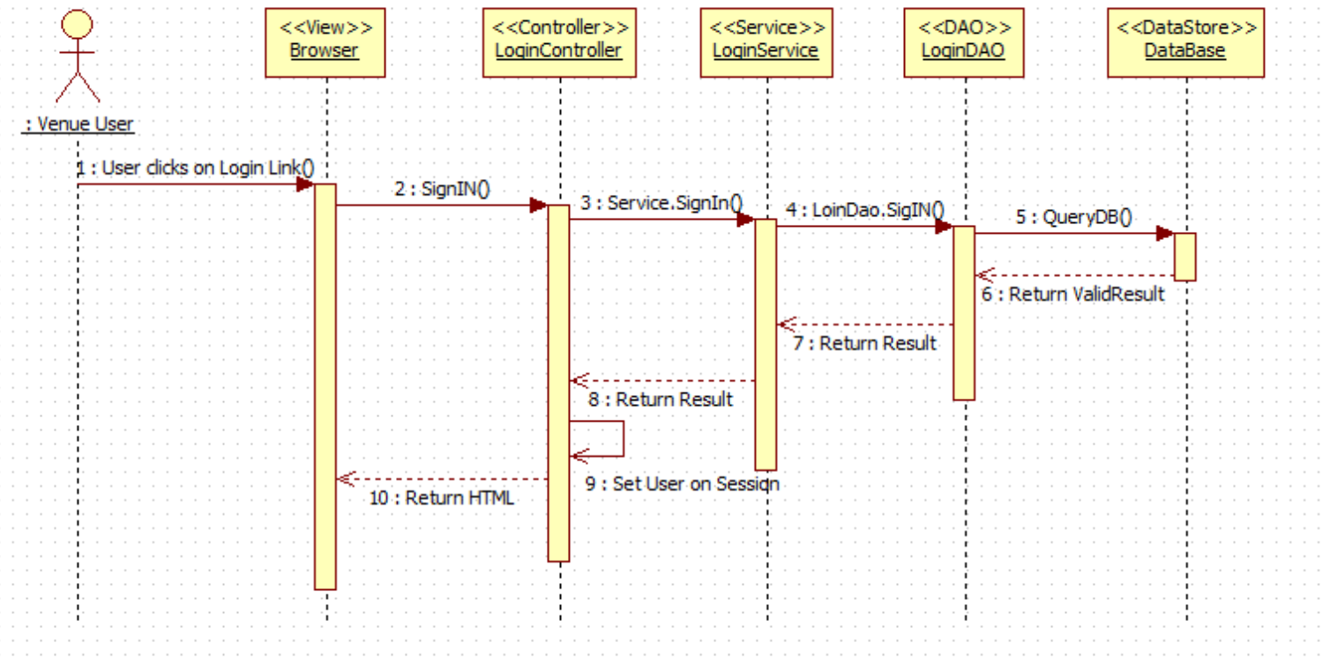

VQ02-Logout:

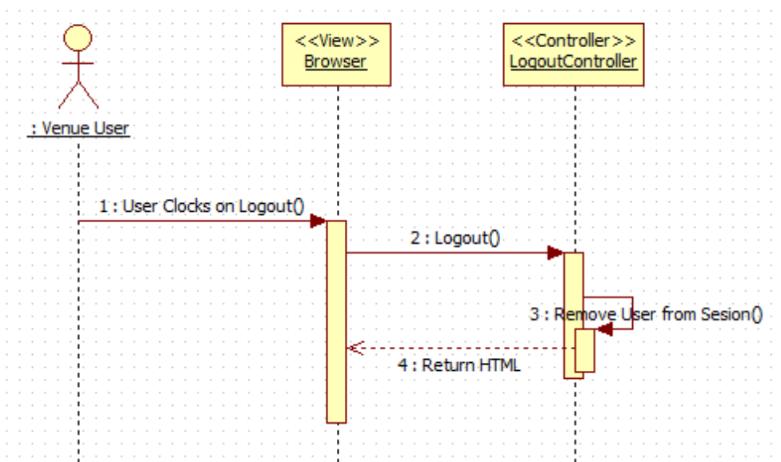

VQ03-Reset Password:

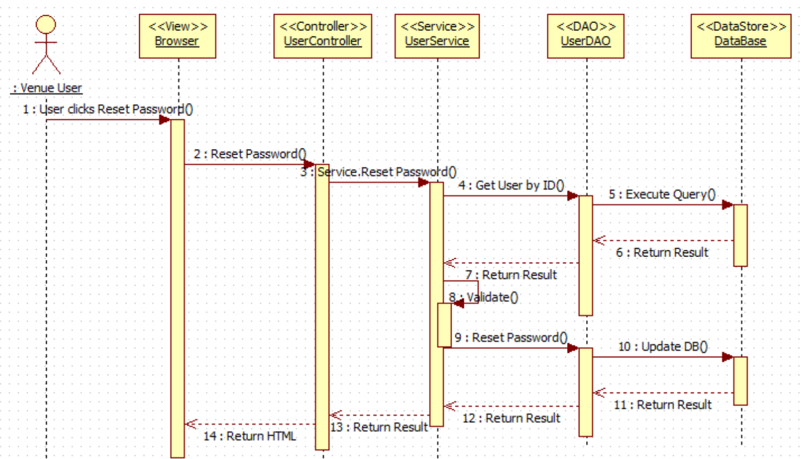

VQ05 - Register New User

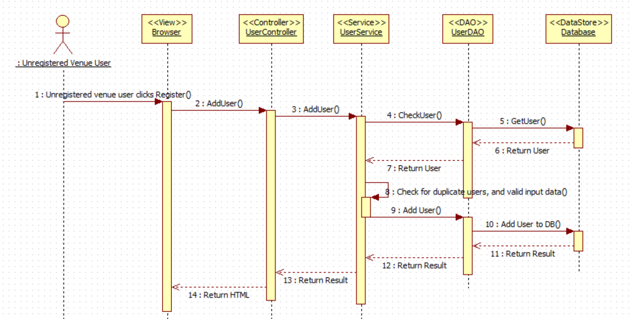

VQ06 – Select Ride

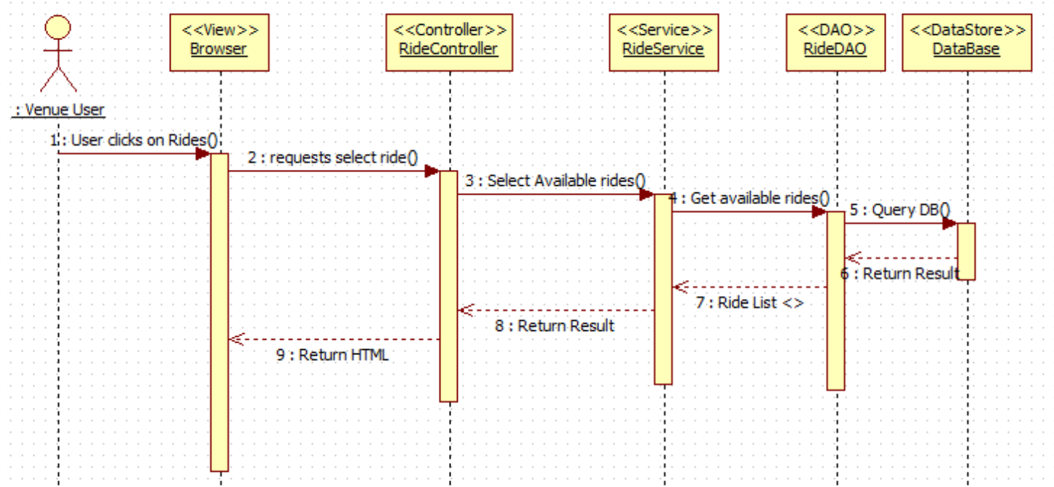

VQ07 – Add Ride (Queue User for Ride)

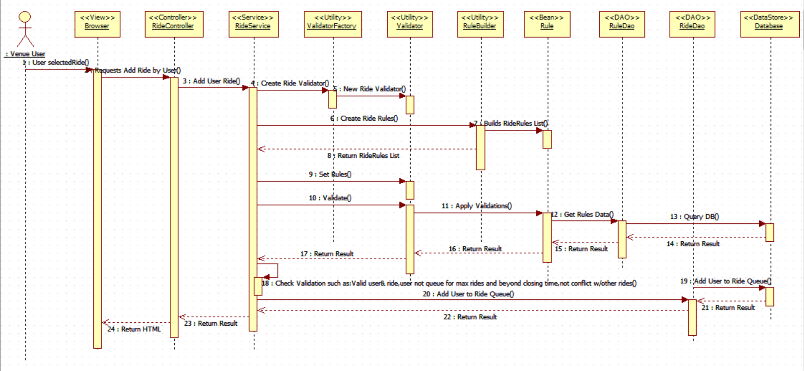

VQ08 - Edit User's Profile

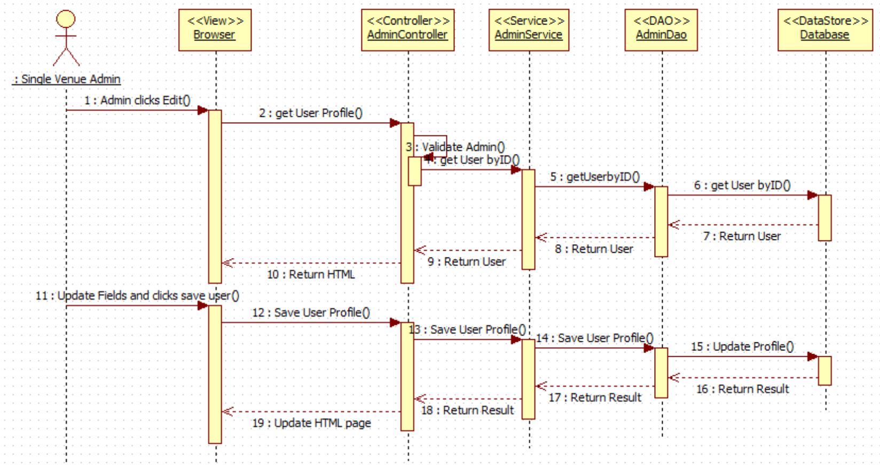

VQ09 - Disable User's Account

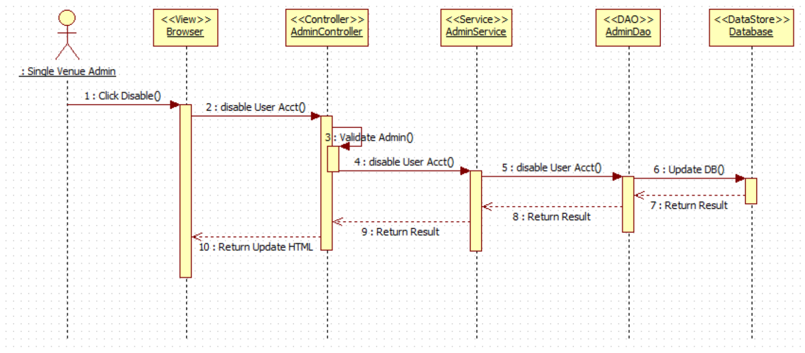

VQ10 - Enable User's Account

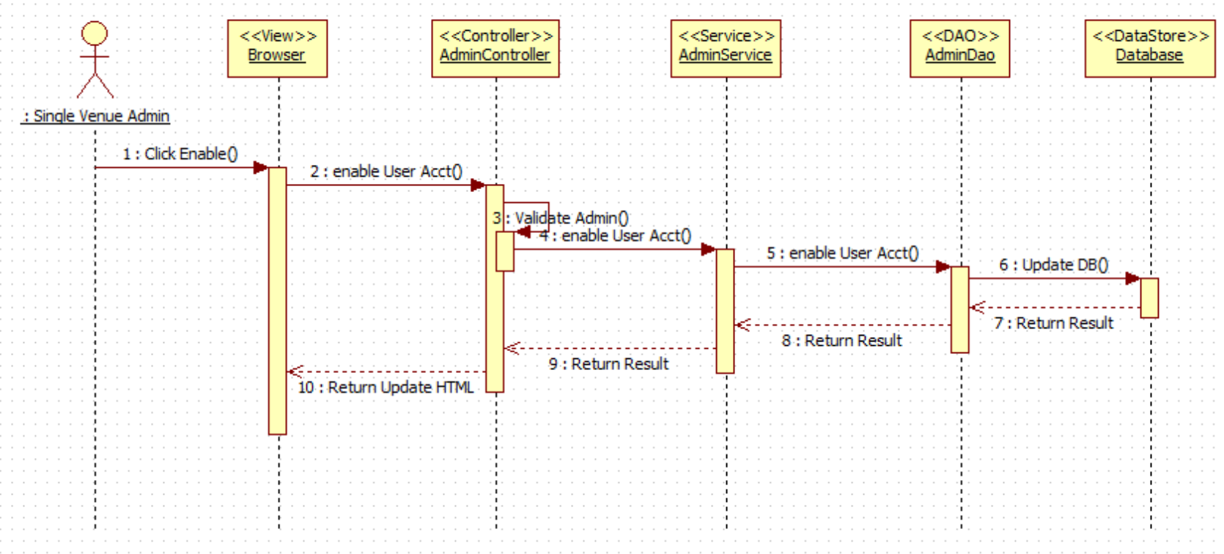

VQ11 – Delete a Registered Ride (De-queue User from Ride)

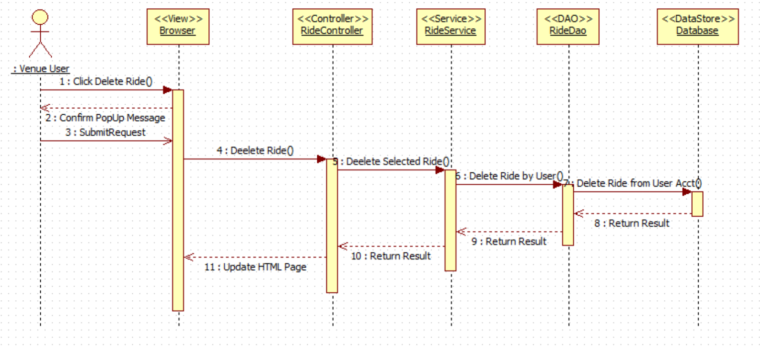

VQ12 – View Available Rides

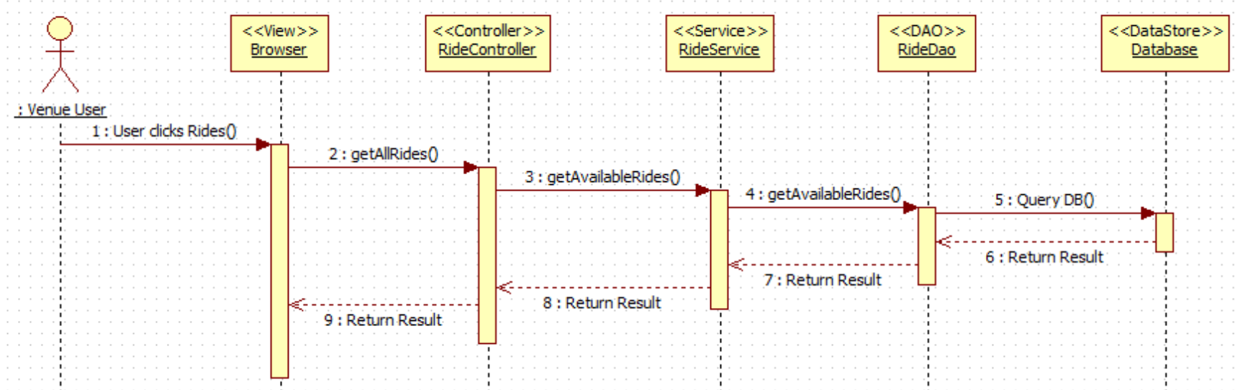

VQ13 – View User Activity

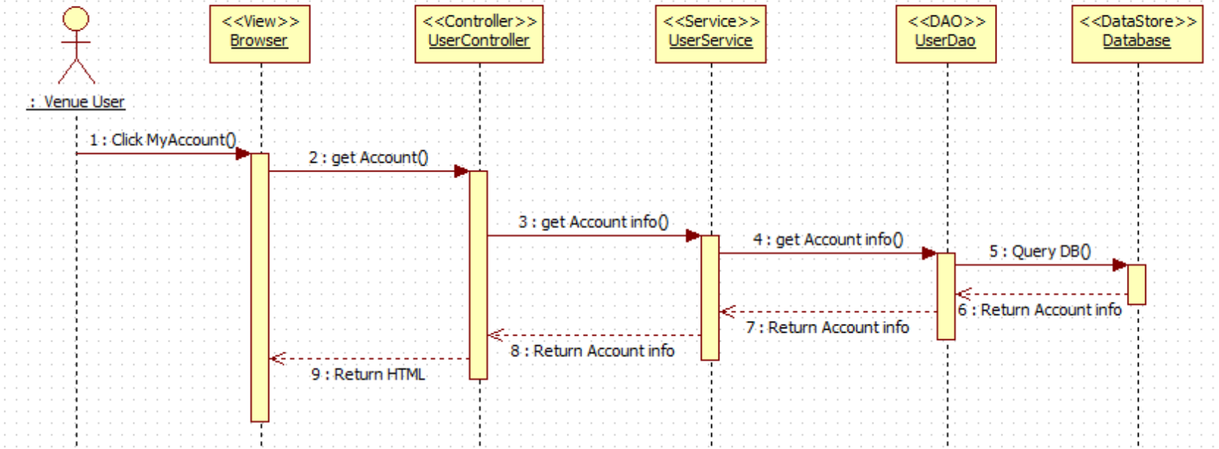

VQ14 – Receive Notification (before ride time approaches)

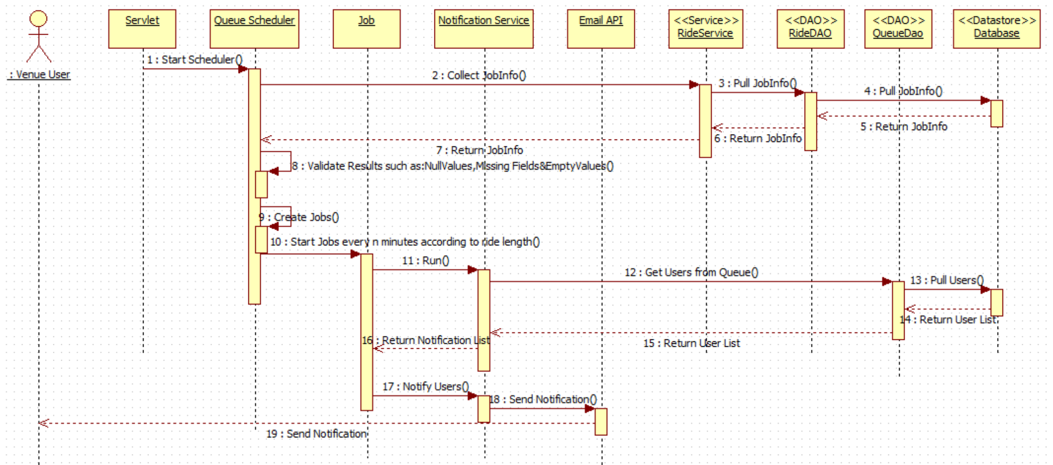

## 6.4 Code Specification

The Virtual Queue has a low coupling system because of the extensive use of interfaces that it has. Each controller of the VQ calls the service interface specified on the path. Following, from each service implementation a call to the data access interface of the VQ is made. So, each layer is independent. Refer to appendix F for the list of all interfaces corresponding to each service and each DAO.

# 7. System Validation

This chapter covers the system validation of the VQ, which will have in detail the testing process of the system. The chapter is composed of two section 7.1 that has Subsystem Tests, covering testing done for each subsystem individual prior to integration and section 7.2 System Tests, covering all the system tests conducted.

## 7.1 Subsystem Tests

In order to test the subsystems below stubs and drivers were created. Refer to appendix G for code details.

|  |  |
| --- | --- |
| **Login/Logout Subsystem** | **Test Description** |
| Login User | Tests user is valid and store user information on session. |
| Logout User | Tests that user is in session and remove it from it. |

|  |  |
| --- | --- |
| **User Operation Subsystem** | **Test Description** |
| Register User | Tests if the system successfully adds a user to the system |
| Retrieve user info by ID | Tests that the id passed exist on the database and retrieve all user data for that specific id. |
| Update user | Tests if user is successfully updated on the database |
| Get All Users | Tests if method returns all users from database |
| Reset Password | Tests if password is successfully changed for a specific user. |

|  |  |
| --- | --- |
| **Ride Operation Subsystem** | **Test Description** |
| Get All Rides | Tests if method returns all rides from the park |
| Get Ride by User id | Tests if method returns all rides related to that user id. |
| Add User to Ride | Tests if user is successfully added to a specific ride. |
| Remove Ride from user | Tests that a user is remove from a ride. |

## 7.2 System Tests

|  |  |
| --- | --- |
| Test Case ID | VQ01_Login_SunnyTest01 |
| Purpose | Test for successful connection to the VQ system with valid username and password. |
| Test Setup | MySQl database must have been setup correctly and program must be running. |
| Input | username: “kcid001@fiu.edu” password: “kely” |
| Expected Results | The user should be granted access to the system and be presented with account page. |

|  |  |
| --- | --- |
| Test Case ID | VQ01_Login_SunnyTest02 |
| Purpose | Test for successful connection to the VQ system with valid username and password. |
| Test Setup | MySQl database must have been setup correctly and program must be running. |
| Input | username: “felineyes151@gmail.com” password: “kely1” |
| Expected Results | The user should be granted access to the system and be presented with account page. |

|  |  |
| --- | --- |
| Test Case ID | VQ01_Login_RainyTest03 |
| Purpose | Test for connection to the VQ system with valid username and incorrect password. |
| Test Setup | MySQl database must have been setup correctly and program must be running. |
| Input | username: “kcid001@fiu.edu” password: “kely1” |
| Expected Results | The system does not allow access to user. |

|  |  |
| --- | --- |
| Test Case ID | VQ02_Logout_SunnyTest04 |
| Purpose | Test for successful logout from the VQ system by logged user. |
| Test Setup | MySQl database must have been setup correctly, program must be running, and user must be logged in. |
| Input | Click the logout button |
| Expected Results | The user is logged out of the VQ system and presented with the Home page. |

|  |  |
| --- | --- |
| Test Case ID | VQ02_Logout_SunnyTest05 |
| Purpose | Test for successful logout from the VQ system by logged user. |
| Test Setup | MySQl database must have been setup correctly, program must be running, and user must be logged in. |
| Input | Click the “X” in the top right corner |
| Expected Results | The user is logged out of the VQ system. |

|  |  |
| --- | --- |
| Test Case ID | VQ02_Logout_RainyTest06 |
| Purpose | Test for successful logout from the VQ system by logged user. |
| Test Setup | MySQl database must have been setup correctly, program must be running, and user must be logged in. System was unexpectedly disconnected from the database |
| Input | User tried to logout with a disconnected database. |
| Expected Results | Unable to logout dialog. |

|  |  |
| --- | --- |
| Test Case ID | VQ03_ResetPass_SunnyTest07 |
| Purpose | Test for successfully resetting password in the VQ system by registered user. |
| Test Setup | MySQl database must have been setup correctly, program must be running, user must be registered and must be on Login menu. |
| Input | User clicks the Reset Password button, fills out the form presented, clicks submit, and try to log back in to the system. |
| Expected Results | User is granted access to the system with the new password. |

|  |  |
| --- | --- |
| Test Case ID | VQ03_ResetPass_SunnyTest08 |
| Purpose | Test for successfully resetting password in the VQ system by registered user. |
| Test Setup | MySQl database must have been setup correctly, program must be running, user must be registered and must be on MyAccount menu. |
| Input | User clicks the Reset Password button, fills out the form presented, clicks submit, and try to log back in to the system. |
| Expected Results | User is granted access to the system with the new password. |

|  |  |
| --- | --- |
| Test Case ID | VQ03_ResetPass_RainyTest09 |
| Purpose | Test for resetting password in the VQ system by registered user with incorrect security answer. |
| Test Setup | MySQl database must have been setup correctly, program must be running, user must be registered and must be on Reset password form. |
| Input | For Username: [test@test.com](mailto:test@test.com), Security answer: two  User fills out the rest of the reset password form presented correctly, and clicks submit. |
| Expected Results | User is requested to enter the correct security answer on the form. |

|  |  |
| --- | --- |
| Test Case ID | VQ04_ConfirmIdent_SunnyTest10 |
| Purpose | Test if correct user by resetting password with valid username and security question. |
| Test Setup | MySQl database must have been setup correctly, program must be running, user must be registered and forgot password. |
| Input | User clicks on Reset Password from Login Page. User enters Username: [test@test.com](mailto:test@test.com), Security answer: one, and fills out the rest of the reset password form presented correctly, and clicks submit. |
| Expected Results | User is validated by the system, and password is correctly changed on the VQ database system. |

|  |  |
| --- | --- |
| Test Case ID | VQ04_ConfirmIdent_SunnyTest11 |
| Purpose | Test if correct user by resetting password with valid username and security question. |
| Test Setup | MySQl database must have been setup correctly, program must be running, user must be registered and must want to reset password. |
| Input | User clicks on Reset Password from Account Page. User enters Username: [test@test.com](mailto:test@test.com), Security answer: one, and fills out the rest of the reset password form presented correctly, and clicks submit. |
| Expected Results | User is validated by the system, and password is correctly changed on the VQ database system. |

|  |  |
| --- | --- |
| Test Case ID | VQ04_ConfirmIdent_SunnyTest12 |
| Purpose | Test if correct user by resetting password with wrong username and security question. |
| Test Setup | MySQl database must have been setup correctly, program must be running, user must be registered and must want to reset password. |
| Input | User clicks on Reset Pasword from Login Page. User enters Username: [test11@test.com](mailto:test11@test.com), Security answer: wrong, and fills out the rest of the reset password form presented correctly, and clicks submit. |
| Expected Results | User is validated and asked to correct the reset password form. Password is not changed on the VQ database system. |

|  |  |
| --- | --- |
| Test Case ID | VQ05_RegisterNewUser_SunnyTest13 |
| Purpose | Test to see if VQ system correctly adds a user to the VQ database. |
| Test Setup | MySQl database must have been setup correctly, program must be running, user requires an account. |
| Input | User clicks on Register button from the Home page, user fills the register form presented correctly, and clicks submit. |
| Expected Results | User is able to log in to the VQ system with the credential chosen. |

|  |  |
| --- | --- |
| Test Case ID | VQ05_RegisterNewUser_SunnyTest14 |
| Purpose | Test to see if VQ system correctly adds a user to the VQ database. |
| Test Setup | MySQl database must have been setup correctly, program must be running, user tries to login to the system without an account. |
| Input | User clicks on Register button from the login page, user fills the register form presented correctly, and clicks submit. |
| Expected Results | User is able to log in to the VQ system with the credential chosen. |

|  |  |
| --- | --- |
| Test Case ID | VQ05_RegisterNewUser_RainyTest15 |
| Purpose | Test to see if VQ system adds a user to the VQ database that already exists. |
| Test Setup | MySQl database must have been setup correctly, program must be running, user chooses to enter an already registered account. |
| Input | User clicks on Register button from Home page, fills the register form presented with username: [test@test.com](mailto:test@test.com) already on database, and clicks submit. |
| Expected Results | User is requested to choose another username because that one is already been used. |

|  |  |
| --- | --- |
| Test Case ID | VQ06_SelectRide_SunnyTest16 |
| Purpose | Test if user can select a ride that is available. |
| Test Setup | MySQl database must have been setup correctly, program must be running, user is logged in. Rides are made available. |
| Input | User clicks on Rides button from the Home page, clicks the dropdown menu presented and selects the desired available ride. |
| Expected Results | VQ system should allow the user to select the desired ride. |

|  |  |
| --- | --- |
| Test Case ID | VQ06_SelectRide_SunnyTest17 |
| Purpose | Test if user can select a ride that is available. |
| Test Setup | MySQl database must have been setup correctly, program must be running, user is logged in. The VQ system has just 3 rides available. |
| Input | User clicks on Rides button from the Home page, clicks the dropdown menu presented and selects one the three available rides. |
| Expected Results | VQ system should allow the user to select the desired ride. |

|  |  |
| --- | --- |
| Test Case ID | VQ06_SelectRide_RainyTest18 |
| Purpose | Test if user can select a ride that is available. |
| Test Setup | MySQl database must have been setup correctly, program must be running, user is logged in. Rides are all unavailable. |
| Input | User clicks on Rides button from the Home page, clicks the dropdown menu presented and tries to select a ride. |
| Expected Results | VQ system should not allow the user to select any ride. |

|  |  |
| --- | --- |
| Test Case ID | VQ12_ViewRides_SunnyTest34 |
| Purpose | Test if users can see the available rides. |
| Test Setup | MySQl database must have been setup correctly, program must be running, user is logged in. Rides are made available. |
| Input | User clicks on Rides button from the Home page, clicks the dropdown menu presented. |
| Expected Results | User can see the rides available at the venue. |

|  |  |
| --- | --- |
| Test Case ID | VQ12_ViewRides_SunnyTest35 |
| Purpose | Test if users can see the available rides. |
| Test Setup | MySQl database must have been setup correctly, program must be running, user is logged in. Some Rides are made available, and others unavailable. |
| Input | User clicks on Rides button from the Home page, clicks the dropdown menu presented. |
| Expected Results | User can see the updated rides available at the venue. |

|  |  |
| --- | --- |
| Test Case ID | VQ12_ViewRides_RainyTest36 |
| Purpose | Test if users can see the available rides. |
| Test Setup | MySQl database must have been setup correctly, program must be running, user is logged in. Rides are all unavailable. |
| Input | User clicks on Rides button from the Home page, clicks the dropdown menu presented. |
| Expected Results | User cannot see any available rides at the venue. |

|  |  |
| --- | --- |
| Test Case ID | VQ12_ViewActivity_SunnyTest37 |
| Purpose | Test if users can see their account activity. |
| Test Setup | MySQl database must have been setup correctly, program must be running, user is logged in and on his/her account page. User has not added any rides yet. |
| Input | No input necessary. |
| Expected Results | User can see his/her account page with no rides added. |

|  |  |
| --- | --- |
| Test Case ID | VQ12_ViewActivity_SunnyTest38 |
| Purpose | Test if users can see their updated account activity. |
| Test Setup | MySQl database must have been setup correctly, program must be running, user is logged in and on his/her account page. User has been added to at least 1 ride. |
| Input | No input necessary. |
| Expected Results | User can see his/her account page with the ride that was added. |

|  |  |
| --- | --- |
| Test Case ID | VQ12_ViewActivity_RainyTest39 |
| Purpose | Test if users can see their account activity. |
| Test Setup | MySQl database must have been setup correctly, program must be running, user is logged in and on his/her account page. User has canceled all rides. |
| Input | No input necessary. |
| Expected Results | User can see his/her account page with no rides. |

## 7.3 Evaluation of Tests

On the table below are each of the system test cases id for the VQ system that were conducted and the actual results.

|  |  |
| --- | --- |
| Test Case ID | Actual Test Results |
| VQ01_Login_SunnyTest01 | PASS |
| VQ01_Login_SunnyTest02 | PASS |
| VQ01_Login_RainyTest03 | PASS |
| VQ02_Logout_SunnyTest04 | PASS |
| VQ02_Logout_SunnyTest05 | PASS |
| VQ02_Logout_RainyTest06 | PASS |
| VQ03_ResetPass_SunnyTest07 | PASS |
| VQ03_ResetPass_SunnyTest08 | PASS |
| VQ03_ResetPass_RainyTest09 | PASS |
| VQ04_ConfirmIdent_SunnyTest10 | PASS |
| VQ04_ConfirmIdent_SunnyTest11 | PASS |
| VQ04_ConfirmIdent_RainyTest12 | PASS |
| VQ05_RegisterNewUser_SunnyTest13 | PASS |
| VQ05_RegisterNewUser_SunnyTest14 | PASS |
| VQ05_RegisterNewUser_RainyTest15 | PASS |
| VQ06_SelectRide_SunnyTest16 | PASS |
| VQ06_SelectRide_SunnyTest17 | PASS |
| VQ06_SelectRide_RainyTest18 | PASS |
| VQ12_ViewRides_SunnyTest34 | PASS |
| VQ12_ViewRides_SunnyTest35 | PASS |
| VQ12_ViewRides_RainyTest36 | PASS |
| VQ12_ViewActivity_SunnyTest37 | PASS |
| VQ12_ViewActivity_SunnyTest38 | PASS |
| VQ12_ViewActivity_RainyTest39 | PASS |

# 8. Glossary

**Actor:** Anyone that can use or misuse the system.

**Database:** A collection of related data.

**Deliverable:** A work product for the client.

**Expected Results:** The results that will be produced when executing a test case if and only if the program satisfies its intended behavior.

**Role:** Associated with a set of tasks assigned to a project participant.

**Test Setup:** A status that must be true before an operation is invoked.

**Stub:** A skeletal or special-purpose implementation of a software module, used to develop or test a module that calls or is otherwise dependent on it.

**System:** Underlying reality.

**System Testing:** Tests all the components together, seen as a single system to identify errors with respect to the scenarios from the problem statement and the goals in the goals in the requirements specification and system design.

**Task:** An atomic unit of work that is both manageable and consumes resources.

**Test Case:** A set of test inputs, execution conditions, and expected results developed for a particular objective, such as to exercise a particular program path or to verify compliance with a specific requirement.

**Test Driver:** A software module used to invoke a module under test and, often, provide test inputs, control and monitor execution, and report test results.

**Input:** The input necessary to complete some execution of the software under test.

**Use Case:** A general sequence of events that defines all possible actions between one or many actors and the system for a given piece of functionality.

**User Interface (UI):** The way through which a user interacts with the computer system.

**Class Diagram:** A pictorial representation of all the classes in the system

**Functional Requirement:** A function supported by the system, where a function is a set of inputs, the behavior, and outputs.

**Non-Functional Requirement:** A requirement that specifies criteria that can be used to judge the operation of a system, rather than specific behaviors.

**Object Diagram:** A pictorial representation of an instance of a class with example of how the data of the class will be populated.

**Sequence Diagram:** A pictorial representation of how processes operate with one another and the user during the course of a specific piece of functionality.

# 9. Appendix

This chapter contains a Gantt Chart with the scheduled time of work for the whole project, all use cases with nonfunctional requirements, the user interface design of the VQ system, static and dynamic diagrams for the analysis model and design models as well, the documented class interfaces and constrains, the documented code for test drivers and stubs, and a diary of meetings for the entire semester.

## 9.1 Appendix A - Project schedule (Gantt chart or PERT Chart)

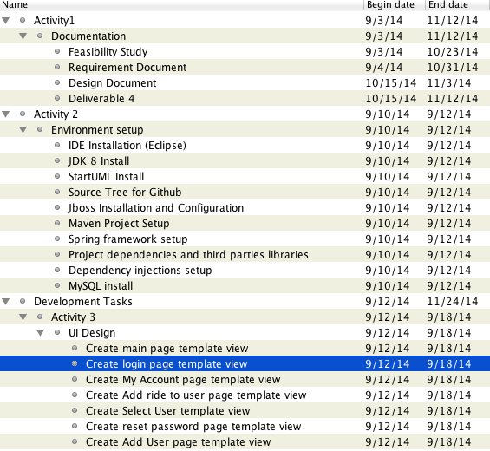

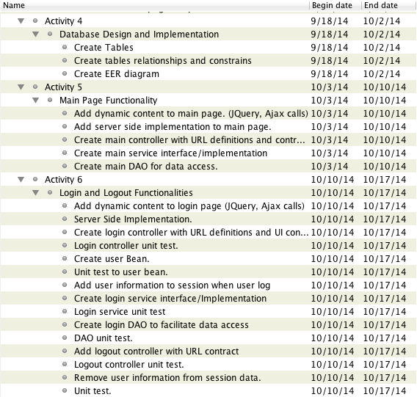

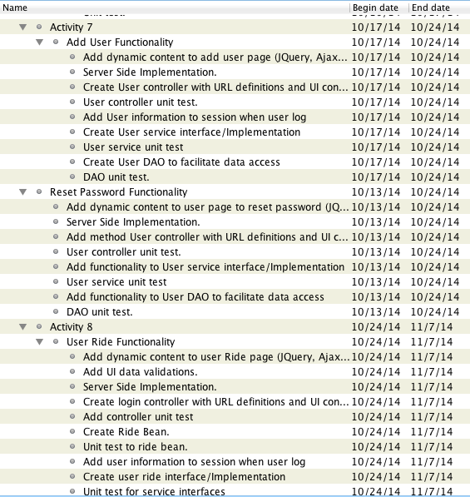

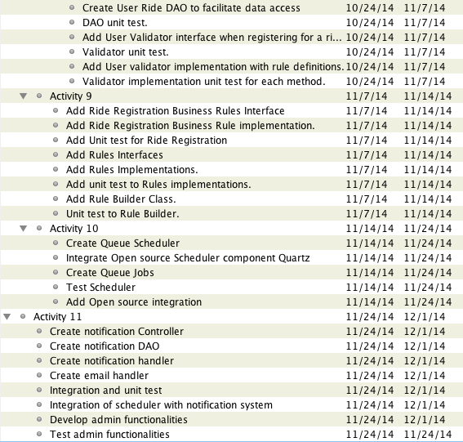

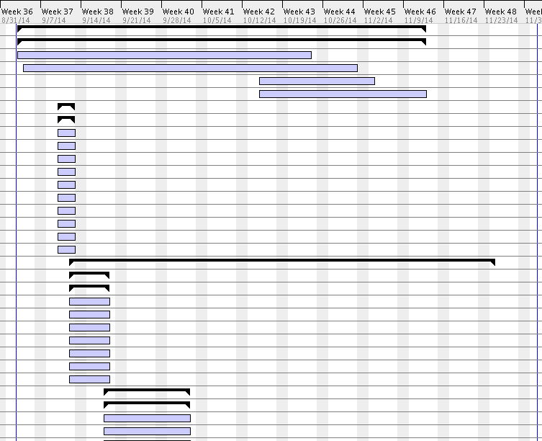

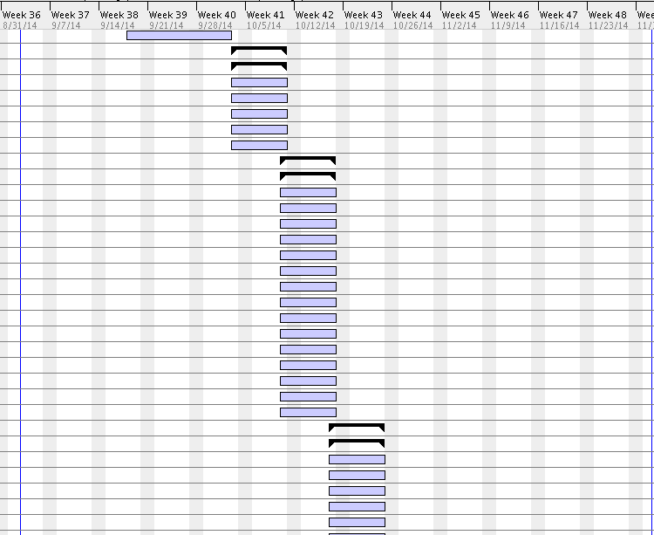

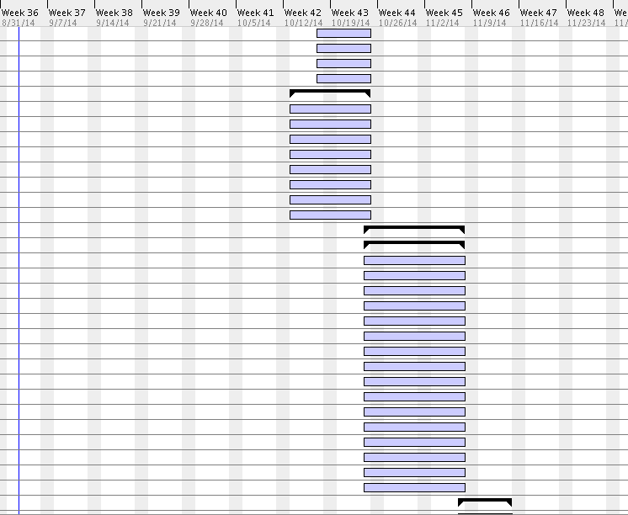

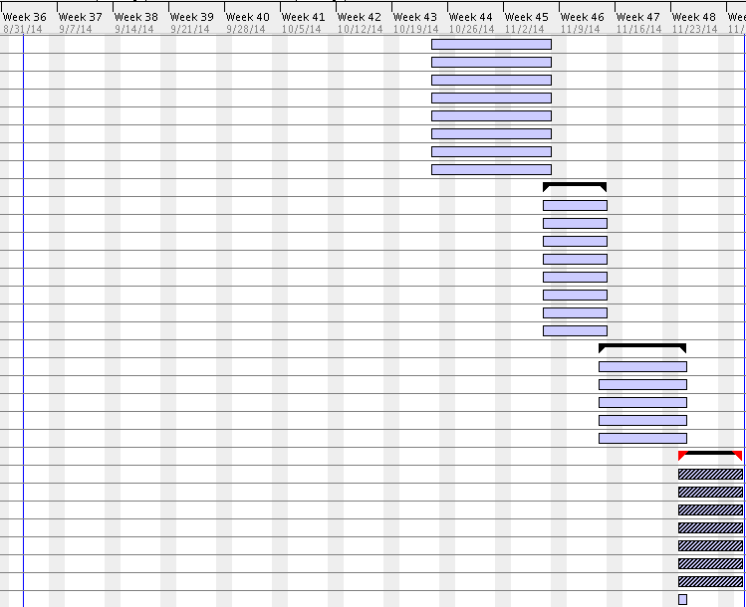

## 9.2. Appendix B – All use cases with nonfunctional requirements

*Use Case ID:* **VQ01 – User Login**

*Actors:* VenueRegistered Visitor, Single Venue Admin.

*Pre-conditions:*

1. Web page has been activated
2. Participants must have a web username and password.

*Description:*

1. Use case begins when the user accesses the login option.
2. The user will be prompted with a data entry template for username and password.
3. The user provides a previously registered user name and password.
4. User shall continue request by accessing the Login.
5. If the credentials are valid, the system will log the user into the corresponding page.
6. Use case ends when access is granted to respective user.

*Relevant requirements:* A user will only be allowed into the system if he/she has a valid username and password.

*Post-conditions:*

1. Access is granted.

*Alternative Courses of Action:*

1. In step 2 of Description section there is an option that allows the user to reset the password if he/she forgot. (see use Case **VQ03 – Reset Password**)

*Exceptions:*

1. The login option on the Website is not active.
2. The option to reset password is not active.
3. The database is not active.

*Related Use Cases:* None.

**Special Requirements:**

* **Usability**: No previous training time. System is simple and easy to follow.
* **Reliability**: The system should perform correctly 99% of the time.
* **Performance**: The system should be sent and saved within 3 seconds.
* **Supportability**: The system should be easy to maintain, make appropriate changes, and be correctly handled by IE, Mozilla, Chrome and Safari.

**\*\*\*\*\*\*\*\*\*\*\*\*\*\*\*\*\*\*\*\*\*\*\*\*\*\*\*\*\*\*\*\*\*\*\*\*\*\*\*\*\*\*\*\*\*\*\*\*\*\*\*\*\*\*\*\*\*\*\*\*\*\*\*\*\*\*\*\*\*\*\*\*\*\*\***

*Use Case ID:* **VQ02 – User Logout**

*Actors:* VenueRegistered Visitor, Single Venue Admin.

*Pre-conditions:*

1. Web page has been activated.
2. User must have been previously logged in.

*Description:*

1. Use case begins when the user accesses the logout option.
2. The system logs the user out.
3. Use case ends when the system logs user out and displays the home screen.

*Relevant requirements:* A user will only be logged out if he/she has previously logged in.

*Post-conditions:*

1. User gets successfully logged out of the system.

*Alternative Courses of Action:*

1. The user closes the webpage.

*Exceptions:*

1. The logout option on the webpage is not active.

*Related Use Cases:* None.

**Special Requirements:**

* **Usability**: No previous training time. System is simple and easy to follow.
* **Reliability**: The system should perform correctly 99% of the time.
* **Performance**: The system should be sent and saved within 3 seconds.
* **Supportability**: The system should be easy to maintain, make appropriate changes, and be correctly handled by IE, Mozilla, Chrome and Safari.

**\*\*\*\*\*\*\*\*\*\*\*\*\*\*\*\*\*\*\*\*\*\*\*\*\*\*\*\*\*\*\*\*\*\*\*\*\*\*\*\*\*\*\*\*\*\*\*\*\*\*\*\*\*\*\*\*\*\*\*\*\*\*\*\*\*\*\*\*\*\*\*\*\*\***

*Use Case ID:* **VQ03 – Reset Password**

*Actors:* VenueRegistered Visitor, Single Venue Admin.

*Pre-conditions:*

1. User must have previously registered into the system.
2. User must be logged out of the system.

*Description:*

1. Use case begins when the user accesses the option to reset password on the login screen.
2. The system will prompt the user with a data entry template.
3. The user should enter username, which will be their registered email, choose their security question, and write their security answer, new password and password confirmation.
4. The user shall complete the form and submit the changes.
5. If the username is on record, the system will update the password notify the user if the request was submitted successfully. (See Use case **VQ04 – Confirm Identity**).
6. Use case ends when the request is stored in the system.

*Relevant requirements:* A user will only be allowed to reset password if he/she has previously registered.

*Post-conditions:*

1. The password gets successfully changed in the database.

*Alternative Courses of Action:*

1. In step 3 of Description section the username could not be found.
2. In step 3 of Description section the user has the option to cancel the request.
3. In step 3 of Description section the answer to the security question does not match the records.
4. In step 4 of Description section the user has the option to cancel the request.

*Extensions:*

1**. VQ04 – Confirm Identity**

*Exceptions****:***

1. The option to reset the password is inactive.
2. The user table in the database is inactive.

*Related Use Cases:* **VQ04 – Confirm Identity.**

**Special Requirements:**

* **Usability**: No previous training time. System is simple and easy to follow.
* **Reliability**: The system should perform correctly 99% of the time.
* **Performance**: The system should be sent and saved within 3 seconds.
* **Supportability**: The system should be easy to maintain, make appropriate changes, and be correctly handled by IE, Mozilla, Chrome and Safari.

**\*\*\*\*\*\*\*\*\*\*\*\*\*\*\*\*\*\*\*\*\*\*\*\*\*\*\*\*\*\*\*\*\*\*\*\*\*\*\*\*\*\*\*\*\*\*\*\*\*\*\*\*\*\*\*\*\*\*\*\*\*\*\*\*\*\*\*\*\*\*\*\*\*\*\*\***

*Use Case ID:* **VQ04 – Confirm Identity**

*Actors:* VenueRegistered Visitor, Single Venue Admin.

*Pre-conditions:*

1. Web Page has been activated.
2. User already has an active access account.
3. User accesses the login option.
4. User accesses the forget password option.

*Description:*

1. Use case begins when the user is prompted with a template for data entry.
2. The user shall enter his username, which is the email, and finish the rest of the reset password form correctly.
3. Use case ends when user clicks on submit button and is presented with the login form.

*Relevant requirements:* none.

*Post-conditions:* The user is taken back to Login.

*Alternative Courses of Action:*

1. In step 1 of the Description section the user can cancel the request.
2. In step 3 of the Description section the ID and/or email are not found.

*Exceptions****:***

1. The system is unavailable.

*Related Use Cases:* VQ03 Reset Password.

**Special Requirements:**

* **Usability**: No previous training time. System is simple and easy to follow.
* **Reliability**: The system should perform correctly 99% of the time.
* **Performance**: The system should be sent and saved within 3 seconds.
* **Supportability**: The system should be easy to maintain, make appropriate changes, and be correctly handled by IE, Mozilla, Chrome and Safari.

*Use Case ID:* **VQ05 - Register New User**

*Actors:* Venue Unregistered Visitor

*Pre-conditions:*

1. Web page has been activated

*Description:*

1. Use case begins when guest user accesses the register option on the Website.

2. The system shall provide the guest user or new administrator with a template for data entry.

3. The guest user should enter the following data: first Name, last name, password, security question, security answer, phone number (for confirmation).

4. The guest user should send the request by accessing the submit option.

5. The system shall then notify the guest user if the request was submitted successfully.

6. When the request is received the system shall update the record for that new user.

7. Use case ends when the record is updated.

*Relevant requirements:*

1. A guest user will only be able to register if they do not have a profile created from before.
2. Registered users (including administrators) will be rejected.

*Post-conditions:*

1. The record for that user has been created.

*Alternative Courses of Action:*

1. In step 4 o the f Description section the user has the option to cancel the request.
2. In step 5 o the f Description section, if any of the required fields are left blank the system shall notify the user of the missing fields.

*Exceptions:*

1. The register option on the webpage is not active.
2. After the user enters the required information the system the user gets rejected.

*Use Cases:* None.

**Special Requirements:**

* **Usability**: No previous training time. System is simple and easy to follow.
* **Reliability**: The system should perform correctly 99% of the time.
* **Performance**: The system should be sent and saved within 3 seconds.
* **Supportability**: The system should be easy to maintain, make appropriate changes, and be correctly handled by IE, Mozilla, Chrome and Safari.

**\*\*\*\*\*\*\*\*\*\*\*\*\*\*\*\*\*\*\*\*\*\*\*\*\*\*\*\*\*\*\*\*\*\*\*\*\*\*\*\*\*\*\*\*\*\*\*\*\*\*\*\*\*\*\*\*\*\*\*\*\*\*\*\*\*\*\*\*\*\*\*\*\*\*\***

*Use Case ID:* **VQ06 – Select Ride**

*Actors:* VenueRegistered Visitor, Single Venue Admin.

*Pre-condition:*

1.      Web page has been activated.

*Description:*

1.      Use case begins when user accesses the option to select a ride.

2.      The system shall display a list of the rides available for the user.

3.      The user shall select the ride/event they want.

4.      Use case ends when the system allows the user to finalize adding their ride (See Use case **VQ07 – Add Ride**).

*Post-conditions:*

1. The system shall update the changes made on the database.

*Alternative Courses of Action:*

1. In step 3 of the Description section the user has the option to cancel the request.
2. In Step 4 of Description section the system notifies that the request could not be completed.

*Exceptions:*

1. The option to select ride/event is not active.
2. The system could not continue after submitting the selection.

*Related Uses case:* **VQ07 – Add Ride**

**Special Requirements:**

* **Usability**: No previous training time. System is simple and easy to follow.
* **Reliability**: The system should perform correctly 99% of the time.
* **Performance**: The system should be sent and saved within 3 seconds.
* **Supportability**: The system should be easy to maintain, make appropriate changes, and be correctly handled by IE, Mozilla, Chrome and Safari.

**\*\*\*\*\*\*\*\*\*\*\*\*\*\*\*\*\*\*\*\*\*\*\*\*\*\*\*\*\*\*\*\*\*\*\*\*\*\*\*\*\*\*\*\*\*\*\*\*\*\*\*\*\*\*\*\*\*\*\*\*\*\*\*\*\*\*\*\*\*\***

*Use Case ID:* **VQ07 – Add Ride**

*Actors:* VenueRegistered Visitor, Single Venue Admin.

*Pre-condition:*

1. Web page has been activated.
2. Venue Registered User has an active account within the system.
3. Venue Registered User has already made a ride selection

*Description:*

1. Use case begins when user has already selected the ride to be added.
2. User shall continue by adding the ride requested.
3. The system shall notify the user if ride was successfully added.
4. Use case ends when customer accepts the notification displayed and user is taken to his/her activity page.

*Post-conditions:*

1. The system shall update the changes made on the database.
2. The number of rides for the customer is increased by one in the database.
3. A unique id is created on the on the queue ride table for that customer.

*Alternative Courses of Action:*

1. In step 2 of the Description section the user has the option to cancel the ride.
2. In Step 4 of Description section the system notifies that the request could not be completed.

*Exceptions:*

1.      The option to add ride is not active.

2.      The option to accept the notification is not active.

3.      The system could not submit the request.

*Related Uses case:* **VQ06 – Select Ride**

**Special Requirements:**

* **Usability**: No previous training time. System is simple and easy to follow.
* **Reliability**: The system should perform correctly 99% of the time.
* **Performance**: The system should be sent and saved within 3 seconds.
* **Supportability**: The system should be easy to maintain, make appropriate changes, and be correctly handled by IE, Mozilla, Chrome and Safari.

**\*\*\*\*\*\*\*\*\*\*\*\*\*\*\*\*\*\*\*\*\*\*\*\*\*\*\*\*\*\*\*\*\*\*\*\*\*\*\*\*\*\*\*\*\*\*\*\*\*\*\*\*\*\*\*\*\*\*\*\*\*\*\*\*\*\*\*\*\*\***

*Use Case ID:* **VQ08 - Edit User's Profile**

*Actors:* Single Venue Admin.

*Pre-conditions:*

1. User has an existing profile.
2. Web page has been activated.
3. User (administrator) has successfully logged onto the system.

*Description:*

1. Use case begins when *Admin search the user to be edited.*
2. Admin accesses the User Profile page and select edit option.
3. Admin is prompted with a data entry template with already loaded user info.
4. Admin can change any field they want (making sure all fields have an entry).
5. User shall accept “Update”.
6. The system shall notify the user if the request was submitted successfully.
7. Admin is taken back to the profile page.
8. Use case ends when the system saves the updated information.

*Relevant requirements:* None.

*Post-conditions:*

1. User's profile is updated in the database.

*Alternative Courses of Action:*

1. In Step 4 of Description section the user has the option to cancel the request.
2. In Step 4 of Description section the system prompt the user to enter more data if a required field is left blank.
3. In Step 5 of Description section the system notifies that the request could not be completed.

*Exceptions:*

1. The update user profile link is not active.
2. The update button is not active.

*Related Use Cases:* None

**Special Requirements:**

* **Usability**: No previous training time. System is simple and easy to follow.
* **Reliability**: The system should perform correctly 99% of the time.
* **Performance**: The system should be sent and saved within 3 seconds.
* **Supportability**: The system should be easy to maintain, make appropriate changes, and be correctly handled by IE, Mozilla, Chrome and Safari.

**\*\*\*\*\*\*\*\*\*\*\*\*\*\*\*\*\*\*\*\*\*\*\*\*\*\*\*\*\*\*\*\*\*\*\*\*\*\*\*\*\*\*\*\*\*\*\*\*\*\*\*\*\*\*\*\*\*\*\*\*\*\*\*\*\*\*\*\*\*\***

*Use Case ID:* **VQ09 - Disable User's Account**

*Actors:* Single Venue Admin.

*Pre-conditions:*

1. User (administrator) has an existing profile.

2. Web page has been activated.

3. User has successfully logged onto the system.

4. User is on his profile page.

*Description:*

1. Use case begins when *Admin search the user to be disabled.*
2. Admin accesses the User Profile page.
3. *Admin* shall access the “Disable” option.
4. The system shall ask the *Admin* if they are sure they want to proceed.
5. The *Admin* shall confirm by accepting the “Yes” option.
6. The system shall notify the *Admin* if the request was submitted successfully.
7. *Admin* is taken back to the Main page.
8. Use case ends when the system saves the updated information.

*Relevant requirements:* none.

*Post-conditions:*

1. Record for user is updated in the database.

*Alternative Courses of Action:*

1. In step 3 of Description section the *Admin* has the option to cancel the request.

*Exceptions:*

1. The system is unavailable.
2. The “Update Profile” option is unavailable.
3. The “Disable” option is unavailable.

*Related Use Cases:* **VQ01 - User Login**

**Special Requirements:**

* **Usability**: No previous training time. System is simple and easy to follow.
* **Reliability**: The system should perform correctly 99% of the time.
* **Performance**: The system should be sent and saved within 3 seconds.
* **Supportability**: The system should be easy to maintain, make appropriate changes, and be correctly handled by IE, Mozilla, Chrome and Safari.

**\*\*\*\*\*\*\*\*\*\*\*\*\*\*\*\*\*\*\*\*\*\*\*\*\*\*\*\*\*\*\*\*\*\*\*\*\*\*\*\*\*\*\*\*\*\*\*\*\*\*\*\*\*\*\*\*\*\*\*\*\*\*\*\*\*\*\*\*\*\*\***

*Use Case ID:* **VQ10 - Enable User's Account**

*Actors:* Single Venue Admin.

*Pre-conditions:*

1. User (administrator) has an existing profile.

2. Web page has been activated.

3. *Admin* has successfully logged onto the system.

4. *Admin* is on his profile page.

*Description:*

1. Use case begins when admin search for the user to be enabled
2. *Admin* finds the user and accesses the "Update User Profile" option.
3. *Admin* is prompted with a data entry template.
4. *Admin* shall access the “enable” option.
5. The system shall ask the *Admin* if they are sure they want to proceed.
6. The *Admin* shall confirm by accepting the “Yes” option.
7. The system shall notify the user if the request was submitted successfully.
8. *Admin* is taken back to the Main page.
9. Use case ends when the system saves the updated information.

*Relevant requirements:* none.

*Post-conditions:*

1. Record for user is updated in the database.

*Alternative Courses of Action:*

1. In step 3 of Description section the *Admin* has the option to cancel the request.

*Exceptions:*

1. The system is unavailable.
2. The “Update Profile” option is unavailable.
3. The “Enable” option is unavailable.

*Related Use Cases:* **VQ01 - User Login**

**Special Requirements:**

* **Usability**: No previous training time. System is simple and easy to follow.
* **Reliability**: The system should perform correctly 99% of the time.
* **Performance**: The system should be sent and saved within 3 seconds.
* **Supportability**: The system should be easy to maintain, make appropriate changes, and be correctly handled by IE, Mozilla, Chrome and Safari.

**\*\*\*\*\*\*\*\*\*\*\*\*\*\*\*\*\*\*\*\*\*\*\*\*\*\*\*\*\*\*\*\*\*\*\*\*\*\*\*\*\*\*\*\*\*\*\*\*\*\*\*\*\*\*\*\*\*\*\*\*\*\*\*\*\*\*\*\*\*\*\*\***

*Use Case ID:* **VQ11 – Delete a Registered Ride**

*Actors:* VenueRegistered Visitor, Single Venue Admin.

*Pre-condition:*

1. Web page has been activated.
2. The user has successfully logged onto the system.
3. User is on his/her account page.
4. There is a user request to remove an already existing ride from his/her account.

*Description:*

1. Use case begins when user selects the option to remove an already existing ride from his/her list.
2. The system shall allow the user to select the cancel option from the specific ride selected.
3. The system shall prompt the user to confirm the option to remove the ride and shall accept.
4. Use case ends when the system displays the changes made.

*Post-conditions:*

1. The system shall update the transaction on the database.

*Alternative Courses of Action:*

1. In step 3 of the Description section the user has the option to cancel the confirmation form and make no changes to his/her account.

*Exceptions:*

1. The option to remove a ride is not active.
2. The option to confirm the changes made to the user account is not active.
3. The ride is not found on the database.

*Related Uses case:* **VQ07 – Add Ride**

**Special Requirements:**

* **Usability**: No previous training time. System is simple and easy to follow.
* **Reliability**: The system should perform correctly 99% of the time.
* **Performance**: The system should be sent and saved within 3 seconds.
* **Supportability**: The system should be easy to maintain, make appropriate changes, and be correctly handled by IE, Mozilla, Chrome and Safari.

**\*\*\*\*\*\*\*\*\*\*\*\*\*\*\*\*\*\*\*\*\*\*\*\*\*\*\*\*\*\*\*\*\*\*\*\*\*\*\*\*\*\*\*\*\*\*\*\*\*\*\*\*\*\*\*\*\*\*\*\*\*\*\*\*\*\*\*\*\*\*\***

*Use Case ID:* **VQ12 – View Available Rides**

*Actors:* Venue Unregistered Visitor, Venue Registered Visitor, Single Venue Admin.

*Pre-condition:*

1. Web page has been activated.

*Description:*

1. Use case begins when user accesses the option to see the rides.
2. User shall be presented with a dropdown menu.
3. Use case ends when the system displays a list of the rides available for the user.

*Alternative Courses of Action:*

1. In step 1 of the Description section the user has the option to cancel the request to see available rides.
2. In Step 2 of Description section the system does not displays the list of rides available to users.

*Exceptions:*

1. The option to see the available rides is not active.
2. The system does not display the list of rides available to users.

*Related Uses case:* None

**Special Requirements:**

* **Usability**: No previous training time. System is simple and easy to follow.
* **Reliability**: The system should perform correctly 99% of the time.
* **Performance**: The system should be sent and saved within 3 seconds.
* **Supportability**: The system should be easy to maintain, make appropriate changes, and be correctly handled by IE, Mozilla, Chrome and Safari.

**\*\*\*\*\*\*\*\*\*\*\*\*\*\*\*\*\*\*\*\*\*\*\*\*\*\*\*\*\*\*\*\*\*\*\*\*\*\*\*\*\*\*\*\*\*\*\*\*\*\*\*\*\*\*\*\*\*\*\*\*\*\*\*\*\*\*\*\*\*\*\***

*Use Case ID:* **VQ13 – View User Activity**

*Actors:* Venue Registered Visitor, Single Venue Admin.

*Pre-condition:*

1. Web page has been activated.
2. The user has successfully logged onto the system.

*Description:*

1. Use case begins when user is taken to his/her account page.
2. The system shall allow the user to see his/her account page.
3. Use case ends when the system displays all info for rides added for that specific user.

*Alternative Courses of Action:*

1. In step 3 of the Description section the user has the option to close the page and not view his/her activity info.

*Exceptions:*

1. User is not taken to his/her account.
2. The system does not display user info.

*Related Uses case:* None

**Special Requirements:**

* **Usability**: No previous training time. System is simple and easy to follow.
* **Reliability**: The system should perform correctly 99% of the time.
* **Performance**: The system should be sent and saved within 3 seconds.
* **Supportability**: The system should be easy to maintain, make appropriate changes, and be correctly handled by IE, Mozilla, Chrome and Safari.

**\*\*\*\*\*\*\*\*\*\*\*\*\*\*\*\*\*\*\*\*\*\*\*\*\*\*\*\*\*\*\*\*\*\*\*\*\*\*\*\*\*\*\*\*\*\*\*\*\*\*\*\*\*\*\*\*\*\*\*\*\*\*\*\*\*\*\*\*\*\*\***

*Use Case ID:* **VQ14 – Received Notification Time**

*Actors:* Venue Registered User, Venue Administrator

*Pre-condition:*

1. Web page has been activated.
2. The user has successfully logged onto the system.
3. The user has successfully selected the ride preferred.

*Description:*

1. Use case begins when user has already added the ride requested to his/het account page.
2. User shall be kept in the ride queue until the time for his/her turn approaches.
3. Use case ends when user receives the notification email with the time for the specific ride before the time approaches.

*Post-conditions:*

1. The system shall update the changes made on the database.

*Alternative Courses of Action:*

1. In step 2 of the Description section the user has the option to cancel their ride from their account page.
2. In Step 3 of Description section the system notifies that the notification could not be sent.

*Exceptions*

1. The system could not send the request.

*Related Uses case:* **VQ06 – Select Ride**

**Special Requirements:**

* **Usability**: No previous training time. System is simple and easy to follow.
* **Reliability**: The system should perform correctly 99% of the time.
* **Performance**: The system should be sent and saved within 3 seconds.
* **Supportability**: The system should be easy to maintain, make appropriate changes, and be correctly handled by IE, Mozilla, Chrome and Safari.

**\*\*\*\*\*\*\*\*\*\*\*\*\*\*\*\*\*\*\*\*\*\*\*\*\*\*\*\*\*\*\*\*\*\*\*\*\*\*\*\*\*\*\*\*\*\*\*\*\*\*\*\*\*\*\*\*\*\*\*\*\*\*\*\*\*\*\*\*\*\*\***

## 9.3. Appendix C – User Interface Designs

**Virtual Queue System Home:**

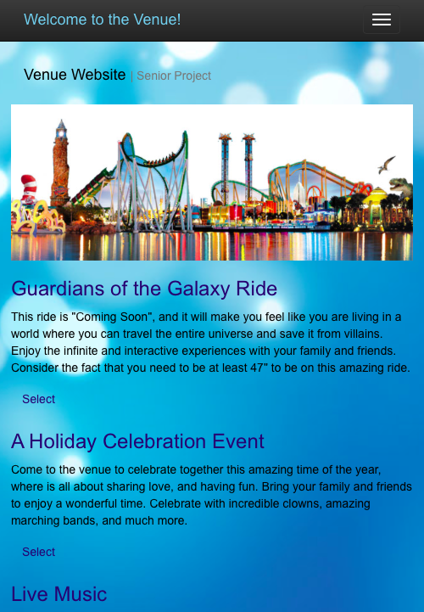

**Virtual Queue System Home w/Menu:**

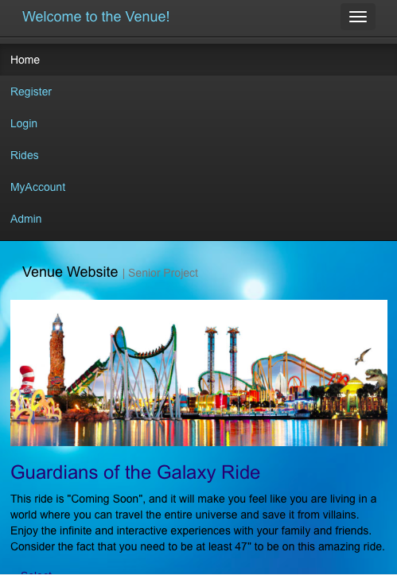

**Virtual Queue System UserLogin:**

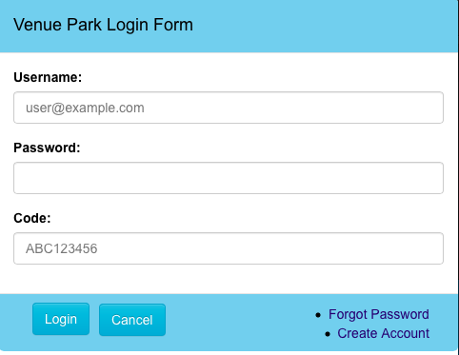

**Virtual Queue System Reset Password:**

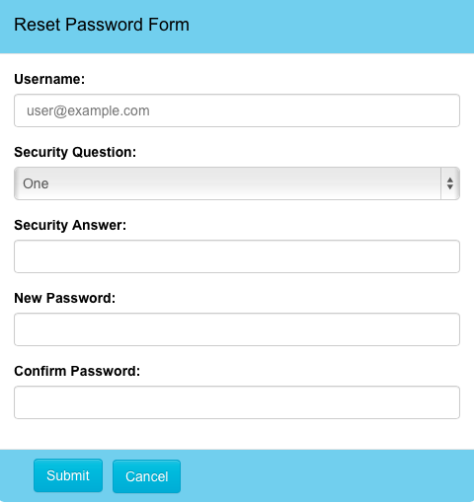

**Virtual Queue System View/Add Rides:**

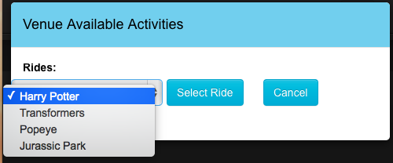

**VirtualQueue System MyAccount (User) Page:**

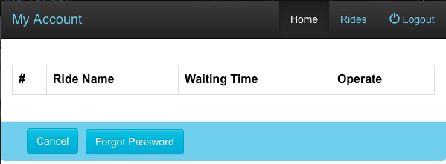

**VirtualQueue System Create Venue User Account:**

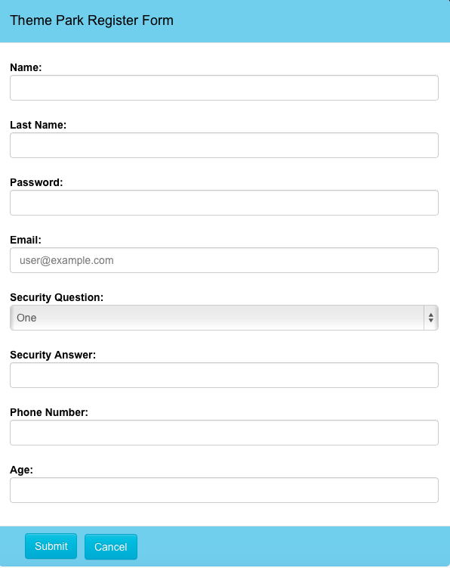

## 9.4. Appendix D – Analysis models (static and dynamic)

## 9.5. Appendix E – Design models (static and dynamic)

To represent the Virtual Queue system design static model, each subsystem was individually represented into a class diagram that describes the behavior and structure of the system so that it will be easier to understand. Below, the figures from 9.5.1 to 9.5.5 are presented.



**Fig 9.5.1: Login Operation Subsystem class diagram (part of the whole VQ class Diagram):**



**Fig 9.5.2: Notification API Subsystem class diagram (part of the whole VQ class Diagram)**



**Fig 9.5.3: Queue Scheduler Subsystem class diagram (part of the whole VQ class Diagram)**



**Fig 9.5.4: Ride Operation Subsystem class diagram (part of the whole VQ class Diagram)**



**Fig 9.5.5: User Operation Subsystem class diagram (part of the whole VQ class Diagram)**

To represent the VQ system design dynamic model, each implemented use case diagram is represented below.

VQ01-Login:



VQ02-Logout:



VQ03-Reset Password:



VQ05 - Register New User



VQ06 – Select Ride



VQ07 – Add Ride (Queue User for Ride)



VQ08 - Edit User's Profile



VQ09 - Disable User's Account



VQ10 - Enable User's Account



VQ11 – Delete a Registered Ride (De-queue User from Ride)



VQ12 – View Available Rides



VQ13 – View User Activity



VQ14 – Receive Notification (before ride time approaches)



## 9.6. Appendix F – Documented class interfaces (code) and constrains

**Class Interfaces (code) for the subsystem Login Operation:**

**package** com.virtual.queue.dao;

**import** com.virtual.queue.beans.User;

**public** **interface** LoginDao {

**public** Long validLogin(String user,String password, String code);

**public** User signIn(String userName,String password, String code);

**public** **boolean** signOut(String userName);

}

**package** com.virtual.queue.service;

**import** com.virtual.queue.beans.User;

**public** **interface** LoginService {

**public** User signIn(String userName, String password, String code);

**public** **boolean** signOut(String userName);

}

**Class Interfaces (code) for the subsystem Notification API:**

package com.virtual.queue.service;

import java.util.List;

import com.virtual.queue.beans.UserQueueInfo;

public interface NotificationService {

public List<UserQueueInfo> pullNotInfo(Integer rideId);

public List<UserQueueInfo> pullAllNotInfo();

public void notifyUser(Integer rideId) throws Exception;

public void notifyAllUsers() throws Exception;

}

package com.virtual.queue.handler;

import com.virtual.queue.beans.NotificationInfo;

import com.virtual.queue.exception.NotificationException;

public interface NotificationHandler {

public void notifiyUser(NotificationInfo info) throws NotificationException;

}

**Class Interfaces (code) for the subsystem User Operation:**

package com.virtual.queue.dao;

import java.util.List;

import com.virtual.queue.beans.User;

public interface UserDao {

public User getUser(String username, String passwd);

public String getCurrentlyAuthenticatedUserName();

public User getUserByToken(String token);

public String storeToken(Long userId);

public List<User> getAll();

public void addUser(User user);

public void updateUser(User user);

public void deleteUserById(Long id);

public User getUserByUserName(String userName);

public Boolean resetPassword(String userName, String securityAnswer,

String securityQuestion, String newPassword) throws Exception;

public User authenticateUser(String userName,String securityQuestion,String securityAnwser);

public User getUserById(long userId);

public boolean removeUserFromQueue(long userId,long rideId);

}

package com.virtual.queue.service;

import java.util.List;

import com.virtual.queue.beans.User;

import com.virtual.queue.request.UserPasswordResetRequest;

public interface UserService {

public User getUser(String username, String passwd);

public String getCurrentlyAuthenticatedUserName();

public User getUserByToken(String token);

public String storeToken(long userId);

public List<User> getAll();

public void addUser(User user);

public void updateUser(User user);

public void deleteUserById(Long id);

public User getUserByUserName(String userName);

public void resetPassword(UserPasswordResetRequest passwordReset) throws Exception;

boolean removeUserFromQueue(long rideId, long userId);

}

**Class Interfaces (code) for the subsystem Queue Scheduler:**

**package** com.virtual.queue.service;

**public** **interface** QueueService {

**public** **boolean** removeUserFromQueue(**long** rideId,**long** userid);

**public** **boolean** removeAllUsersFromQueue(**long** rideId);

}

package com.virtual.queue.dao;

import java.util.LinkedList;

import java.util.List;

import com.virtual.queue.beans.QueueInfo;

import com.virtual.queue.beans.UserQueueInfo;

import com.virtual.queue.beans.RideInfo;

import com.virtual.queue.beans.User;

public interface QueueDao {

public List<UserQueueInfo> pullInfo(Integer rideId);

public List<UserQueueInfo> pullAllInfo();

public LinkedList<User> getAllUserQueueForRide(long rideId);

public QueueInfo getQueueInfoByRideId(long rideId);

public boolean removeUserFromQueue(long rideId, long userid);

public boolean removeAllUsersFromQueue(long rideId);

public LinkedList<RideInfo> getRideListByUser(long userId) throws Exception;

}

**Class Interfaces (code) for the subsystem Ride Operation:**

package com.virtual.queue.dao;

import java.util.List;

import com.virtual.queue.beans.RideInfo;

import com.virtual.queue.exception.NotificationException;

public interface RideDao {

public List<RideInfo> pullRideInfo() throws NotificationException ;

public List<RideInfo> getRideByUser(Long userId) throws NotificationException;

public RideInfo getRideById(long rideId) throws NotificationException;

public boolean addUserRideById(Long rideId, Long userId);

public List<RideInfo> getAll();

}

package com.virtual.queue.builder;

import java.util.List;

import com.virtual.queue.rule.Rule;

public interface RuleBuilder {

public List<Rule> buildRules();

}

package com.virtual.queue.validator;

import java.util.List;

import com.virtual.queue.rule.Rule;

public interface Validator {

public void setRules(final List<Rule> rules) throws Exception;

public boolean validate(long userId,long rideId);

}

package com.virtual.queue.service;

import java.util.List;

import org.springframework.stereotype.Service;

import com.virtual.queue.beans.Ride;

import com.virtual.queue.beans.RideInfo;

import com.virtual.queue.beans.User;

import com.virtual.queue.exception.NotificationException;

public interface RideService {

public List<RideInfo> getAll();

public void addRide(Ride ride);

public void updateRide(Ride ride);

public void deleteRideById(Long id, Long userid);

public boolean removeRidebyId(String id);

public boolean addUserRideById(Long rideId, Long userid) throws Exception;

public List<RideInfo> pullRideInfo();

public RideInfo getRidebyId(long rideId) throws NotificationException;

public List<RideInfo> getRidesByUser(long userId) throws NotificationException;

}

**package** com.virtual.queue.rule;

**public** **interface** Rule {

**public** **void** loadData(**long** userId,**long** rideId) **throws** Exception;

**public** **boolean** apply();

**void** loadData();

}

## 9.7. Appendix G – Documented code for test drivers and stubs

## 9.8. Appendix H – Diary of Meetings and Tasks for the entire semester

**Virtual Meeting 1:**

**Date:** September 2, 2014

**Start Time:** 9:16PM

**Participating members:** Kely Cid, Bernard Parenteau.

**Agenda:** Programming Background discussion.

**Virtual Meeting 2:**

**Date:** September 3, 2014

**Start Time:** 12:45PM

**Participating members:** Kely Cid, Bernard Parenteau.

**Agenda:** Agreed on a optimized website development for the Virtual Queue System, and discussed Virtual Queue system requirements.

**Virtual Meeting 3:**

**Date:** September 3, 2014

**Start Time:** 3:48PM

**Participating members:** Kely Cid, Bernard Parenteau.

**Agenda:** Agreed to go forward with project requirements, technologies and tools.

**Meeting 4:**

**Date:** September 3, 2014

**Start Time:** 6:20PM

**End Time:** 8:35PM

**Participating members:** Kely Cid.

**Agenda:** Understanding of the project objectives and goals, and started working on Chapter 1 & 2 of the feasibility and project plan document.

**Meeting 5:**

**Date:** September 4, 2014

**Start Time:** 2:10PM

**End Time:** 5:30PM

**Participating members:** Kely Cid.

**Agenda:** Continue working on Chapter 2 of the feasibility and project plan document, and chapter 1 of requirement document.

**Meeting 6:**

**Date:** September 5, 2014

**Start Time:** 2:00PM

**End Time:** 6:00PM

**Participating members:** Kely Cid.

**Agenda:** Continue working on Chapter 2 & 3 of the requirement document, and chapter 3 of feasibility and project plan document. Created Trello Account.

**Meeting 7:**

**Date:** September 6, 2014

**Start Time:** 1:00PM

**End Time:** 7:10PM

**Participating members:** Kely Cid.

**Agenda:** Continue working on Chapter 3, 4, 5, and part of 6 of the requirement document.

**Meeting 8:**

**Date:** September 7, 2014

**Start Time:** 11:00AM

**End Time:** 12:45PM

**Participating members:** Kely Cid.

**Agenda:** Update Trello Account, create Power Point presentation.

**Meeting 9:**

**Date**: September 14, 2014

**Start Time**: 10:30AM

**End Time**: 7:50PM

**Participating members**: Kely Cid, Bernard Parenteau.

**Agenda**: Discussed and Worked on UI design. Update mentor on project. Uploaded mockups for approval on Trello account of Login, Select Ride, and Reset Password and received feedback for mockups.

**Meeting 10:**

**Date**: September 16, 2014

**Start Time**: 10:30AM

**End Time**: 7:50PM

**Participating members**: Kely Cid, Bernard Parenteau.

**Agenda**: Update mentor on project. Define views, controllers, models and url end point contracts for server side end points and test it with static data before connecting UI with server side controller. Database design and implementation.

**Meeting 11:**

**Date**: September 22, 2014

**Start Time:** 1:00PM

**End Time**: 10:45PM

**Participating members**: Kely Cid.

**Agenda**: Keep working on UI design. Added dynamic features to pages. Created packages to group controllers (Home Controller, Login Controller), services (Login Service), and DAO's. interfaces and implementation (Login DAO). Create SQl queries, JDBC prepared statements, pull data from db and manipulate data to build domain objects with data return. Posted half of use cases on Trello for approval. Received approval of Use case diagram V2 for VQ system.Uploaded code to GitHub account. Create unit tests for controllers, and DAO’s.

**Meeting 12:**

**Date**: September 23, 2014

**Start Time:** 1:00PM

**End Time**: 10:45PM

**Participating members**: Kely Cid, Bernard Parenteau.

**Agenda**: Update mentor on project. Discuss Mockups design and use cases for VQ system were uploaded to Trello. Created packages to group controllers (Notification Controller, Queue Controller, User Controller), services (Notification Service, Queue Service, User Service) interfaces and implementations, and DAO's. interfaces and implementation (Queue DAO, User DAO) and interface and implementation handler (Notification handler). Create SQl queries, JDBC prepared statements, pull data from db and manipulate data to build domain objects with data return. Create unit tests for controllers, and DAO’s.

**Meeting 13:**

**Date**: September 25, 2014

**Start Time**: 10:30AM

**End Time**: 7:50PM

**Participating members**: Kely Cid, Bernard Parenteau.

**Agenda**: Update mentor on changes for Feasibility document and feasibility matrix and updates on provided VM with all tools needed already installed.

**Meeting 14:**

**Date**: September 30, 2014

**Start Time**: 10:30AM

**End Time**: 7:50PM

**Participating members**: Kely Cid, Bernard Parenteau.

**Agenda**: Approval received for Mockups designs. Created packages to group controllers (Ride Controller), services (Ride Service) interfaces and implementations, and DAO's. interfaces and implementation (Ride DAO). Create SQl queries, JDBC prepared statements, pull data from db and manipulate data to build domain objects with data return. Create unit tests for controllers, and DAO’s.

**Meeting 15:**

**Date**: October 2, 2014

**Start Time**: 10:00AM

**End Time**: 8:00PM

**Participating members**: Kely Cid, Bernard Parenteau.

**Agenda**: reevaluate Register and Login functionalities and update them to finish it. Started working on Design document and discuss and asked for approval of the rest of use cases. Updated Requirement document and sequence diagrams.

**Meeting 16:**

**Date**: October 7, 2014

**Start Time**: 9:30AM

**End Time**: 5:30PM

**Participating members**: Kely Cid, Bernard Parenteau.

**Agenda**: Preliminary UI design approved on Trello.

**Meeting 17:**

**Date**: October 10, 2014

**Start Time**: 9:30AM

**End Time**: 5:30PM

**Participating members**: Kely Cid, Bernard Parenteau.

**Agenda**: Discuss and understand the process of Selecting and Adding a Ride by a user functionalities and all validations to take into account for ride and each user. Created User rules interface and implementations, Rule DAO interface and implementation, rule Builder interface and implementation. Create SQl queries, JDBC prepared statements, pull data from db and manipulate data to build domain objects with data return. Create unit tests for new DAO’s created.

**Meeting 18:**

**Date**: October 15, 2014

**Start Time**: 11:00AM

**End Time**: 6:25PM

**Participating members**: Kely Cid.

**Agenda**: Continue working on the Feasibility document, Requirement document, and Design document and functionalities of the system. Update mentor on project.

**Meeting 19:**

**Date**: October 20, 2014

**Start Time**: 9:30AM

**End Time**: 5:30PM

**Participating members**: Kely Cid, Bernard Parenteau.

**Agenda**: Update mentor on project. Continue working on the Feasibility document, Requirement document, and Design document to finish them, started first chapters of Final Document. Reevaluate implemented code for logout and reset password and validation rules for adding a ride by a venue user. Created Queue Scheduler to create and schedule queue jobs (Notify user based on ride properties). Create SQl queries, JDBC prepared statements, pull data from db and manipulate data to build domain objects with data return. Fixed and updated some use cases to Trello.

**Meeting 20:**

**Date**: November 7, 2014

**Start Time**: 2:00 PM

**End Time**: 7:20 PM

**Participating members**: Kely Cid, Bernard Parenteau.

**Agenda**: Update mentor on project. Continue working on the Final Document. Created another job on the Queue scheduler to remove users from the Queue. Refine some code implementation, made some bug fixes, and work on admin functionalities. Test system on those functionalities, and subsystem.

**Meeting 20:**

**Date**: November 14, 2014

**Start Time**: 1:10 PM

**End Time**: 6:00 PM

**Participating members**: Kely Cid, Bernard Parenteau.

**Agenda**: Update mentor on project. Mainly worked on the Final Document. Made some new updates on the UI, made some bug fixes and create new tests for the system.

# 10. References

Images used:

1. <http://www.plan-family-reunions.com/themeParks.html>
2. http://ru.forwallpaper.com/wallpaper/abstract-circles-patterns-dots-light-colors-bokeh-abstraction-172728.html